**OpenAI API with Python Bootcamp Notes:**

Notes taken for “OpenAI API with Python Bootcamp: ChatGPT API, GPT-4, DALL-E” by Andrei Dumitrescu and Crystal Mind Academy.

From course description: “*Learn ChatGPT API with Python. Integrate OpenAI Models like GPT-4 with your Python applications. Project-based course*.”

Notes taken by Travis Rillos. These notes and all app code and practice code organized in the following Github repository: <https://github.com/xroadtraveler/open-ai-api-python-bootcamp>.

**Project List:**

* **Project 1:** Zero-Shot sentiment analysis using ChatGPT.
* **Project 2:** Building a ChatGPT clone from scratch (Chat-bot).
* **Project 3:** Building a healthy daily meal plan.
* **Project 4:** YouTube videos summary generator.
* **Project 5:** Program like a pro with Gpt-4.
* **Project 6:** Boost your Linux Sysadmin capabilities with ChatGPT (ShellGPT).
* **Project 7:** GPT-4 text embeddings.

**Table of Contents**

Section 1 – Getting Started: 5

Course Introduction: 5

Setting Up the Environment: Jupyter Notebook and Google Colab: 5

Instructor’s Note: Join My Private Community: 6

Course Resources: 6

Section 2 – Deep Dive into OpenAI API: ChatGPT, GPT-4, GPT-3, DALL-E, Whisper: 7

Creating an OpenAI Account and an API Key: 7

Storing API Key as an Environment Variable: 7

Installing the OpenAI API Library and Authenticating to OpenAI: 8

OpenAI Models: 12

Making GPT-3 Requests Using the OpenAI API: 14

Making ChatGPT Requests Using the OpenAI API: 16

Diving into ChatGPT: 20

Diving into GPT-4: 22

Capability: 22

Alignment: 22

Training Data Timing/Dates: 23

GPT-4 Risks and Limitations: 23

Future: 23

OpenAI API Costs: 24

• Usage 24

• Pricing 24

• Tokens 24

Tokens: 25

OpenAI Model Completion Parameters: 28

• Temperature 29

• top_p 30

• max_tokens 31

• n 31

• “stop” sequence 32

• frequency_penalty 33

• presence_penalty 35

ChatGPT System Role: 36

Prompt Engineering: 38

Best Practices 38

• 1) Latest Model 38

• 2) Put the instructions at the beginning of the prompt 38

• 3) Be specific, descriptive 39

• 4) Start with zero-shot 41

• 5) Reduce “fluffy” and imprecise descriptions 42

• 5) Don’t say what NOT to do, say what to do instead 42

• 7) Give hints (for Code) 43

Image Generation Using the DALL-E Model: 45

Full Code, so far: 51

Using DALL-E to Create Variations and Edit Images: 52

Creating Variations: 52

Editing Images: 54

Diving into DALL-E: 59

DALL-E 3 Risks and Limitations: 60

Introducing ChatGPT and Whisper APIs: 61

Transcription: 61

Translation: 63

Section 3: Project #1: Zero-Shot Sentiment Analysis Using ChatGPT: 65

Project Requirements: 65

Building the Application: 66

Testing the Application: 68

Test 1: Basic Tests: 68

Test 2: Useful Example: Classifying Reviews: 70

Test 3: Useful Example: Fake News Detector: 72

Building a Front-End Using Streamlit: 75

Section 12: [Appendix]: Creating Web Interfaces for ML/DS Applications Using Streamlit: 77

Section Resources: 77

Introduction to Streamlit: 77

Template: Code Box: 78

# Section 1 – Getting Started:

## Course Introduction:

* Just an overview.
* This course requires some basic Python programming knowledge (check).
* There are **11 Sections**.

## Setting Up the Environment: Jupyter Notebook and Google Colab:

* Hmm, looks like we’ll be using **Jupyter Notebook** for this course rather than something like VSCode.
  + The instructor noted that Jupyter Notebooks is probably the most popular Python development environment for **mac**hine **lea**rning, **de**ep **lea**rning, **da**ta **sci**ence, and **da**ta **vis**ualization.
* In this lecture, he shows how to install Jupyter Notebook. However, I already have it, having used it on a previous Python course.
* The instructor also noted that if you ***prefer*** to use any other IDE such as **PyCharm** or **VSCode**, you are free to do so.
  + At the end of the day, it doesn’t matter where you write your code, as long as it works.
  + I may try to simultaneously run things in both Jupyter Notebook and VSCode like I did for several course projects in the past. This allows me to get practice in both, and I might also get to test out the **CodeGPT extension** for VSCode in some real use-cases.
* The name “Jupyter” is an indirect acronym of the *three core languages* it was designed for: **Julia**, **Python**, and **R** (I did not know that).
  + It’s a web application that runs in the browser, that can run live Python code, visualizations, etc.
* After installing Jupyter, he created a directory to store Jupyter files for the course. I took this opportunity to create my own directory as well as a Github repo for course files.
* Once we had our directory created, we opened Jupyter Notebook in said directory using the command line. Once it was open in our default browser, we created a new notebook and gave it the name “**learn_python**”.
  + From here he just showed some of Jupyter’s basic functionality. Pretty basic stuff.
  + He started by showing that you can use Markdown in Jupyter by selecting it from the dropdown menu (by default, this is set to “Code”).
    - The four options in the dropdown menu are:
      * Code
      * Markdown
      * Raw NBConvert
      * Heading
  + He ended the lecture by saying that you can use **Google Colab** exactly like Jupyter Notebook, especially in cases where you’re unable to download/use Jupyter Notebook, or perhaps don’t have the right permissions.
  + Google Colab has many commonly used Python libraries already installed.

## Instructor’s Note: Join My Private Community:

“I have created a private and exclusive[Online Discord Community](https://discord.gg/Q8G7n4PuHd) to provide you with improved, faster, and better support for your course-related questions.

Moreover, you are going to use this Community to better interact with your course colleagues and to help out others whenever I'm not around.

[CLICK HERE TO JOIN THE COMMUNITY NOW!](https://discord.gg/Q8G7n4PuHd)

Lots of companies around the world use Discord to communicate across teams therefore it’s a valuable tool for you as you advance to becoming a valuable Engineer.

And don't forget to subscribe to my [Channel](https://www.youtube.com/c/andreidumitrescu) for video tutorials on Programming, Networking, Information Security, Blockchain, or other Cutting-Edge Technologies!”

## Course Resources:

“All files used in this course (notebooks included) used in this course are available as a **Google Drive Shared Directory**.

You can access the course resources here: <https://drive.google.com/drive/folders/1_eaig9xr88G_ZeA7lPeY-QM_89OtT3XE?usp=share_link>

The best way to learn to program is to write every piece of code by yourself so I encourage you to do so and if you get stuck to check it with my examples.

Many scripts are ready to be used in your Network Environment with no or very few changes.”

# Section 2 – Deep Dive into OpenAI API: ChatGPT, GPT-4, GPT-3, DALL-E, Whisper:

## Creating an OpenAI Account and an API Key:

* This section is about creating an OpenAI account and an API key (I already have both).
* What is an API?
  + API (Application Programming Interface) is a mechanism that enables two software components to communicate with each other using a set of definitions and protocols.
  + We can use an API key to talk to OpenAI’s models with our applications using HTTP requests.

### Storing API Key as an Environment Variable:

* **Note:** Since I’ll be committing my programs for this class to a public Github repo, I decided to look into using an ***Environment Variable*** on my Windows 10 machine to keep a secret API key secret. I created a new secret key just for class uses, then stored that key as an Environment Variable using “Advanced System Settings” in Windows.

## Installing the OpenAI API Library and Authenticating to OpenAI:

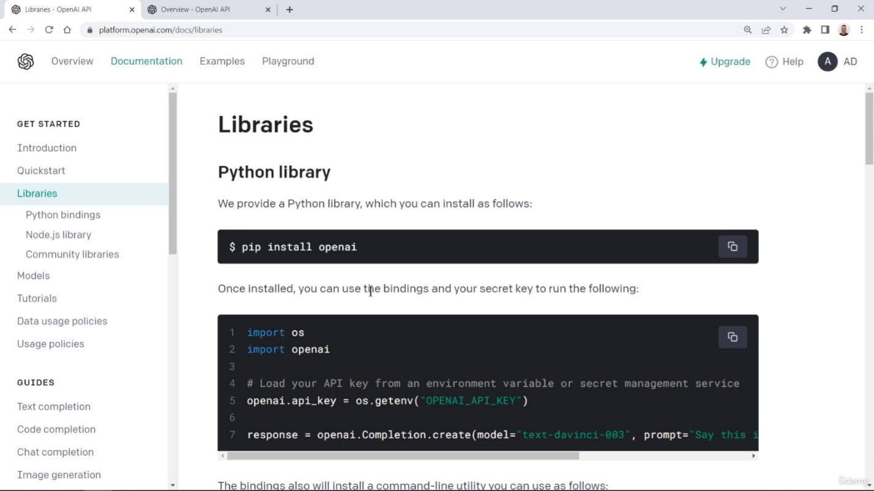

* There are native libraries for OpenAI in **Python** and **Node.js**, plus *community libraries* for many other programming languages such as C#/.NET, Go, Java, et. al.
* We opened Jupyter Notebook in our directory and created a new Notebook, naming it “**01_openai_authentication**”.
  + Note: I had already used **pip install openai** on my main Python installation at some point in the past, so I wonder if I’d be able to skip any of this.
  + He showed how to install from the line “**import openai**” written as the first line in a program in the PyCharm IDE. Guess you can right-click and select “install” in some IDEs.
* Inside a Jupyter Notebook cell, we can install OpenAI in the ***local environment*** by typing the line…
  + **!pip install -q openai**
  + …and then running the cell. Don’t forget the *exclamation mark* at the beginning.
    - The “**-q**” flag stands for “**quiet**” and makes it so **pip** gives less output.
  + He also showed that you can do the exact same thing in **Google Colab**.
* After installing in Jupyter, we comment out the “pip” line, then write the two lines…
  + **import openai**
  + **import os**
  + …directly below it. Run the cell again.
* In order to *use* OpenAI in Python, we have to ***authenticate*** it. We do this with the ***OpenAI API key*** that we created.
* The recommended way to do this is to set the ***secret key*** as an ***environment variable***. We can do this using the **os module** that we just imported.
* In order to *use* OpenAI in Python, we have to ***authenticate*** it. We do this with the ***OpenAI API key*** that we created.
* The recommended way to do this is to set the ***secret key*** as an ***environment variable***. We can do this using the **os module** that we just imported.
  + Example:
    - **os.environ[‘x’] = ‘abc’**
  + In this example, we’ve created an ***environment variable*** called ‘**x**’ and we’ve given it the value of ‘**abc**’.
  + To retrieve this variable, we write:
    - **os.getenv(‘x’)**
  + Since I was already planning on committing my programs to a Github repo and want to maintain security, I’ve already set my secret key as an environment variable using Windows settings. I’ve named it “**OPENAI_CLASS_API_KEY**”. Let’s see if running **os.getenv(‘OPENAI_CLASS_API_KEY’)** works.
    - It worked!!!
    - Sweet.
  + The instructor showed himself doing the same. He noted that if you set your secret API key as an environment variable with this method, you should delete that line/cell afterwards in order to keep it secret.
  + Next we’ll set the variable **openai.api_key**:

import openai

import os

openai.api_key = os.getenv('OPENAI_CLASS_API_KEY') **🡨 🡨 🡨**

* + My VSCode version:
  + The instructor’s Jupyter Notebook screen:

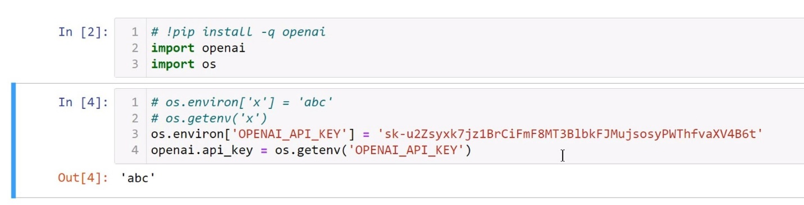

* At this point, the instructor noted that instead of presenting the secret key in plaintext as we’ve been doing so far, you can ***prompt the user*** for their secret key and set it to that.
* To do this, the **getpass** module is an alternative to the built-in user input function. To use it we need to write **import getpass**.
* The code should look something like this:
* The code should look something like this:

import openai

import os

import getpass **🡨 🡨 🡨**

# openai.api_key = os.getenv('OPENAI_CLASS_API_KEY')

key = getpass.getpass("Past your API Key: ") **🡨 🡨 🡨**

openai.api_key = key **🡨 🡨 🡨**

* Or, in Jupyter Notebook, the prompt shows up right underneath the cell you’ve just run:

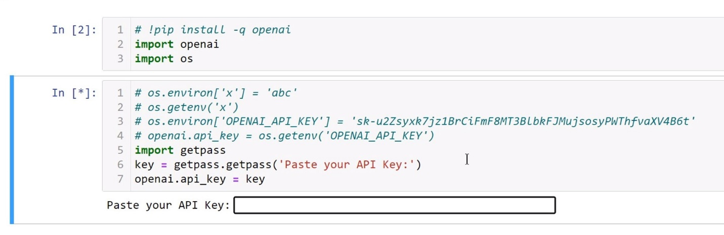

* + The user would *paste* their API key here, setting it as our openai.api_key variable without exposing it as *plaintext*.
* The last solution to input your secret key is to ***load it from offline***. In this example, the instructor had a .txt file called **key.txt** in his Jupyter Notebook session:

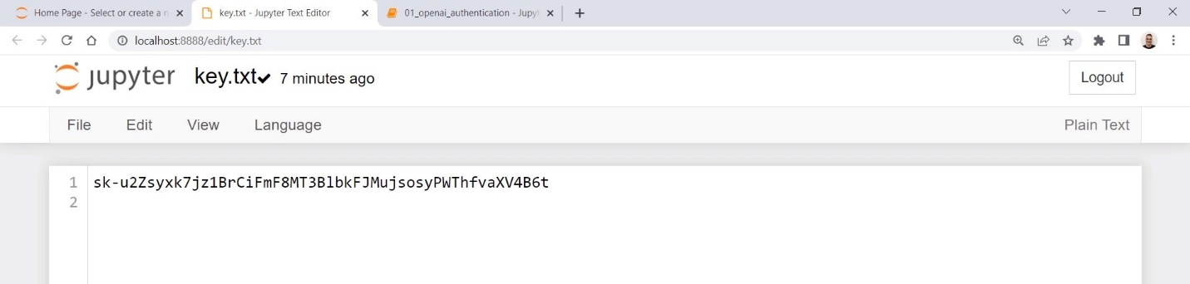

* The code to do this is:
  + **openai.api_key = open(‘key.txt’).read().strip(‘\n’)** – (I’m assuming the .txt file needs to be in the same directory/level as your program in this line).
* The code to do this is:
  + **openai.api_key = open(‘key.txt’).read().strip(‘\n’)** – (I’m assuming the .txt file needs to be in the same directory/level as your program in this line).

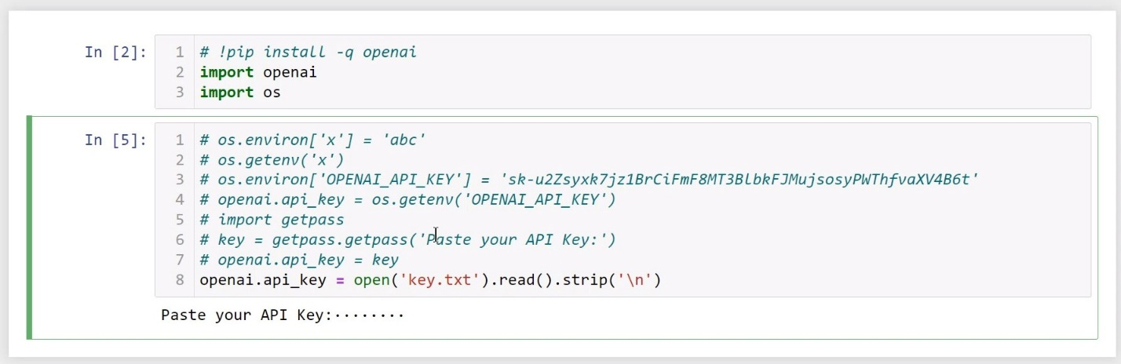

* + So with this, your ***opening*** the text file in *read* mode (the default for open()), ***reading*** it as a *string*, and then the **.strip()** method is optional, but some users add a new line at the end of a .txt file and this needs to be removed.
* So we’ve gone over ***three methods*** of loading your API key securely, and we can use any of these methods for the remainder of this section. Personally I’m just going to call my ***environment variable*** because I already set it the other day, and it should be usable for any programs we write for this course.

## OpenAI Models:

* So we’ve opened our OpenAI accounts, gotten our secret API key, and stored the key as an environment variable. The next step would be to start making *requests* to the OpenAI Models.
  + We’ll do that soon, but for the moment we’re going to ***learn about the AI Models*** that are available to choose from.
* **AI Models:** An AI Model is a software program that uses specific ML and DL algorithms and has been trained on a set of data to perform specific tasks.
* The OpenAI API has access to a family of models, each with different capabilities.
  + At the time this lecture was recorded, these included GPT-3.5, DALL-E, Whisper, Embeddings, Codex, Moderation, and GPT-3, though recently GPT-4 was also released.
    - Models can be modified for specific use-cases; this is called “model fine-tuning”.
  + **GPT-3** consists of various simpler models such as **davinci**, which is the most capable, but also (at the time of recording) the most expensive. On the other hand, **text-ada-001** is the simplest, the fastest, and the cheapest. The other models within GPT-3 are in-between.
    - You can find information about pricing for any model in the “Pricing” tab/URL.
  + **GPT-3.5** is a family of models that improve on GPT-3’s features. Its simplest/fastest/cheapest model is **gpt-3.5-turbo**, which is optimized to generate both *natural language* and *code*, create embeddings, edit text, and other tasks. GPT-3.5’s most advanced model is **text-davinci-003**.
    - **ChatGPT** is (by default) powered by **GPT-3.5** (though now GPT-4 is also an option for paid accounts). However, if you have very simple tasks and a limited budget, you can take the other models into account.
    - Keep in mind that any task that can be performed by a simpler model like **ada** can also be performed by a more sophisticated model like **davinci**.
  + You can use the **Playground** to run and compare different models, settings, output, and response times.
    - To show this off, he chose to compare **ada** and **davinci** using the question “is the capital of France”. Starting off with **text-davinci-003**, and it answered “Paris”. It was smart enough to assume that this was meant to be a question, and answered it.
    - Trying the same thing with **text-ada-001** gave the result “Paris is the capital of France”. Instead of simply answering, it went and filled in the blank and returned the entire sentence. This is acceptable.
  + In the Playground, let’s now try a more complicated task such as a translation.
    - In **text-davinci-003**, he entered “Translate the following text from English to Romanian” followed by “Text: How are you today?” on the next line and then “Translation:” on the next.
      * The model was able to add “Cum esti azi?” after “Translation:”. Pretty smart.
    - Next we run the exact same task using **text-ada-001**. The simpler model just returned “How are you day?”, which isn’t even correct in English. It wasn’t able to complete the task, so **ada** has failed.
* Some of the slider options on the righthand side, such as “**Temperature**” and “**Frequency penalty**” will be discussed later in the course.
* Aside from the GPT-3 and GPT-3.5 models, there are other models as well.
  + **DALL-E** can generate images from text descriptions.
  + **Whisper** can convert audio into text. It’s capable of *multilingual speech recognition* as well as *speech translation* and *language identification*.
* This has been an overview of some of OpenAI’s most important AI models. In the next lecture we’ll use GPT-3 and ChatGPT requests using the OpenAI API in Python.

## Making GPT-3 Requests Using the OpenAI API:

* GPT is often used to process text and generate responses to given prompts. This is what many Large Language Models (LLMs) are geared towards.
* It’s important to think carefully about what prompts to use in order to get the desired output. As a result of this, a *new field* known as ***prompt engineering*** is now emerging.
* In this lecture, we want to make requests to the GPT API, to a text-completion AI model.
  + The most powerful models in the current family (pre-GPT-4) are **davinci** and **GPT-3.5**.

prompt = "Write a motto for a football team"

* We can create a *Python variable* to store our prompt:
* Using this prompt variable, we can make *specific requests* using either **davinci** or **GPT-3.5**; we get to choose which one we use.
  + We can use the **openai.Completion.create()** method to do this, and we can store that as a variable called **response**.
  + Inside this method, we can also use ***keyword arguments*** so we don’t have to worry about the order of the arguments. One such keyword argument is the ***model name***, and others include **temperature** and **max_tokens**:

prompt = "Write a motto for a football team"

response = openai.Completion.create(

    model='text-davinci-003',

    prompt=prompt,

    temperature=0.8,

    max_tokens=1000

)

* So what is ***temperature***?
  + The **temperature** is the parameter that controls how much **randomness** is in the output.
  + The higher the temperature, the more random the answer will be.
  + It can be anywhere between **0** and **2**, and the default is **1**. If you set it to 0, the output will be very deterministic and repetitive. If you set it higher, the output will be more diverse, but also more prone to errors.
* The **max_tokens** variable is the maximum number of tokens to be generated in the *completion*. This limit can vary based on which AI model we use.
  + Note that both **temperature** and **max_tokens** are *optional* parameters.
* Once we have our OpenAI/response stuff working, we want to **print(response)** in order to see the output:
* Once we have our OpenAI/response stuff working, we want to **print(response)** in order to see the output:

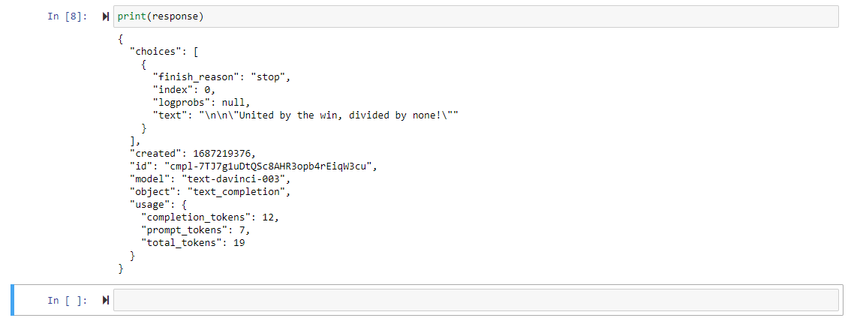

* The response I received read “***Uni****ted* ***b****y* ***t****he* ***w****in,* ***div****ided* ***b****y* ***no****ne!*”. The instructor’s was “***Tea****mwork* ***Ma****kes* ***T****he* ***Dr****eam* ***Wo****rk!*”.
* It comes in as a **JSON object**, something similar to a Python ***dictionary***. In order to extract just the response, we the *value* of the ***key***: “choices”. This gives us a ***list*** of *one element*, another dictionary, which we can extract using index **[0]**:

r = response['choices'][0]

* Then we **print(r)** and this gives us another ***dictionary***, one of *four* elements. We can extract the *value* from the *key*: “**text**”. So let’s add that key on the end:

r = response['choices'][0]['text'] **🡨 🡨 🡨**

* This gives us just the text response on its own!
* In the next lecture, we’ll learn how to make ***ChatGPT requests***.

## Making ChatGPT Requests Using the OpenAI API:

* In the previous video, we talked about using **davinci** for making requests.
* In this video, we focus on making requests to **ChatGPT**, which is powered by **GPT-3.5** and is **optimized for dialogue**.
* In a new Jupyter cell, we’ll make a **new prompt**.
  + We can **opt**imize **ea**ch **pro**mpt **f**or a **spe**cific **A**I **mo**del.
  + But for the moment, we’ll use a standard question.
  + Instead of sending a single phrase as we did in the previous example, for **ChatGPT** **w**e **ne**ed **t**o **se**nd **a li**st/**dict**ionary **o**f **mess**ages.
* We’ll start by creating our new prompt:

prompt = 'Tell me the name of the largest city in the world.'

* Next we need to build the structure of our message:

prompt = 'Tell me the name of the largest city in the world.'

messages = [

    {},

    {},

    {}

]

* Each object or message in the list has **t**wo **prop**erties: the **role** and the **content**.
  + The **roles** can be:
    - System
    - User
    - Assistant
  + The **content** contains the **te**xt **o**f **t**he **mes**sage of the role.
* **Conversations** can be as short as one message or they can fill many pages.
  + The conversations are typically formatted are formatted by a **system message** first, followed by a **user message**.
  + The system message helps **s**et **t**he **beh**avior of the **assistant**. We can instruct the bot to play a specific role.
  + The **user message** is what you ask the assistant. They can be sent by the end-users of an application or be set by the developer as an instruction.
* So let’s start by adding the **system role** and **content**:
* So let’s start by adding the **system role** and **content**:

prompt = 'Tell me the name of the largest city in the world.'

messages = [

    {'role': 'system', 'content': 'Answer as concisely as possible.'}, **🡨 🡨 🡨**

    {},

    {}

]

* Now let’s add the **user** **role** and **content**:

prompt = 'Tell me the name of the largest city in the world.'

messages = [

    {'role': 'system', 'content': 'Answer as concisely as possible.'},

    {'role': 'user', 'content': prompt} **🡨 🡨 🡨**

]

* + (Note: We’ll also *remove* the system role because we don’t need it in this case)
* Next, we create the **completion object**:

response = openai.ChatCompletion.create(

    model='gpt-3.5-turbo',

    messages=messages,

    temperature=0.8,

    max_tokens=1000

)

* For this, we can use either **gpt-3.5-turbo** or **gpt-4** since both of them use the *same* **ChatCompletion** object.
  + We’ll use gpt-3.5-turbo in this case because it’s cheaper.
  + We also set the parameter **messages** to our variable ‘**messages**’, and we set the optional variables temperature and max_tokens.
* We then run the cell or program, and **print(response)**. The answer we were given (inside a dictionary again) is “Tokyo”.
  + Note that ChatGPT is not connected to the internet, so it might not have the latest information.
  + Here’s the full response dictionary:

{

"choices": [

{

"finish_reason": "stop",

"index": 0,

"message": {

"content": "Tokyo.",

"role": "assistant"

}

}

],

"created": 1687307041,

"id": "chatcmpl-7TfvdIZ1vxfrGIUWI7ca5cqpjsggW",

"model": "gpt-3.5-turbo-0301",

"object": "chat.completion",

"usage": {

"completion_tokens": 3,

"prompt_tokens": 33,

"total_tokens": 36

}

}

* If we just want to print the content as text, we run:

print(response['choices'][0]['message']['content'])

* + This results in the output “**Tokyo**”.
* Note that we can get the same thing with:

print(response['choices'][0].message.content)

* + This gives us the same result, but uses the properties of objects instead of indexing.
* Now let’s talk more in-depth about the **system role**.
  + The **system role message** allows us to ***s****et* ***t****he* ***beh****avior* of the **assistant**.
  + In this example, the assistant was **inst**ructed **t**o **ans**wer **t**he **que**stion **a**s **con**cisely **a**s **poss**ible.
  + We can change this to instruct it to **answer the question as detailed as possible**:
* We can change this to instruct it to **answer the question as detailed as possible**:

prompt = 'Tell me the name of the largest city in the world.'

messages = [

    {'role': 'system', 'content': 'Answer as **detailed** as possible.'}, **🡨 🡨 🡨**

    {'role': 'user', 'content': prompt}

* + This resulted in this response:

The largest city in the world by population is Tokyo, Japan. As of 2021, the population of Tokyo is approximately 37 million people in the metropolitan area, making it one of the most populous cities on Earth.

* We can even have it play a specific role. Let’s say we want it to ***answer as Yoda from Star Wars***:

prompt = 'Tell me the name of the largest city in the world.'

messages = [

    {'role': 'system', 'content': 'Answer as **Yoda from Star Wars**.'}, **🡨 🡨 🡨**

    {'role': 'user', 'content': prompt}

* + Which resulted in this:

The name of the largest city in the world, you seek. Answer, I have. Tokyo, it is.

* Since this is a fast-changing technology, it could be useful to keep your knowledge up-to-date by reading the **documentation** at:
  + <https://platform.openai.com/docs/guides/gpt/chat-completions-api>
* Up next, we’ll dive deeper into ChatGPT to see how it really works.

## Diving into ChatGPT:

*Note: Resources for this lecture include links to the PDF files “Training language models to follow instructions with human feedback”, “Attention Is All You Need”, the OpenAI “Research Index” (*[*https://openai.com/research*](https://openai.com/research)*), and a YouTube video titled “State of GPT” (*[*https://www.youtube.com/watch?v=bZQun8Y4L2A*](https://www.youtube.com/watch?v=bZQun8Y4L2A)*, 42 min)*.

**How ChatGPT Works:**

* The models that power ChatGPT focus on the following areas:
  + Large Language Models (LLMs)
  + Self-Attention Mechanism
  + Reinforcement Learning from Human Feedback (RLHF)
* **GPT** – “**Gen**erative **Pr**e-**trai**ned **Trans**former”.
  + A **transformer** is a deep learning model that adopts the mechanism of self-attention, to differentiate the significance of each part of the input data using weights.
  + Large Language Models digest larges amounts of text data and infer the relationships between words within the text.
  + LLMs increase their capabilities as the size of their input datasets and parameter space increase.
* **LLM Issues and Limitations:**
  + - Capability.
    - Alignment.
  + **Capability** is the mode’s ability to perform a specific task or how well it is able to optimize its objective function.
  + **Alignment** is concerned with what we actually want the model to do versus what it has been trained to do (if model’s goals and behavior align with human values and expectations).
* Large Language Models, such as the GPT-3 family of models are ***misaligned***.
  + This is because they are trained on vast amounts of text data from the internet, and are capable of generating human-like text, but they may not always produce output that is consistent with human expectations or desired values.
  + This misalignment is due to their object function, which is a probability distribution over word sequences that allows them to predict what the next word is in the sequence.
* **Align**ment **pro**blems **i**n **La**rge **Lang**uage **Mod**els (LLMs):
  + Model hallucinations.
  + Lack of interpretability.
  + Generating biased or toxic output.
* Now let’s see how a model can produce a misalignment.
* Now let’s see how a model can produce a misalignment.
* **GPT-3** family of models are generative models.
  + Core techniques:
    - Next-token Prediction.
    - Masked-language Modeling.
  + **Next-token Prediction**: the model is given a sequence of words as input, and it is asked to predict in a reasonable human-like way the next word in the sequence.
  + **Masked-language Modeling:** some of the words in the input are replaced with a special token, such as **[MASK]**. The model should predict the correct word that should be inserted in the place of the mask.
    - As an example, the instructor input the phrase…
      * “The area of a circle is **[MASK]** times the radius squared”
    - …and GPT output
      * “The area of a circle is **π** times the radius squared”.
    - However, since this is based on the *probability* that a word belongs in a phrase, the instructor used the example of…
      * “The Roman Empire **[MASK]** with the reign of Augustus”.
    - He noted that due to the way the word probability works, GPT could fill in the blank with either “**began**” or “**ended**”, but only one of these is factually correct.
* To overcome this possible misalignment in LLMs, OpenAI uses a technique called “**Reinforcement Learning from Human Feedback**” (RLHF).
  + ChatGPT is the first case of the use of this technique for a model put into production.
  + To find out more in-depth about what RLHF really means, the instructor asked ChatGPT. The AI output an in-depth explanation of how RLHF is meant to work.
  + RLHF is a ***training technique*** used by deep learning models. They interact with the environment and receive feedback in the form of rewards or penalties based on their actions.
  + The model also receives feedback from a human expert who provides guidance on how to improve its performance.
  + Human feedback can take various forms, such as:
    - Correcting misclassifications.
    - Providing additional training data.
    - Suggesting changes to the model architecture.
* In the following lectures, we’ll cover some other important concepts used by LLMs such as the GPT family. We’ll cover tokens, model completion parameters in-depth, the system role, and prompt engineering.

## Diving into GPT-4:

*Note: Resources for this lecture include the PDF files “GPT-4_Technical_Report”, “Sparks of Artificial General Intelligence: Early Experiments with GPT-4”, and “GPT-4-System-Card”*.

* **GPT-4** is a large **multimodal** model that accepts both text and images as input and generates text as output.
* It can work on documents with text and photos, diagrams, or screenshots.
* Remember back to this:
  + **Capability:** model’s ability to perform a specific task.
  + **Alignment:** to what extent the model’s goals and behavior align with human values and expectations.

### Capability:

* While less capable than humans in real world scenarios, GPT-4 exhibits human-level performance on various professional and academic benchmarks.
  + **GPT-4** has been tested by taking multiple **academic exams** that were originally meant for humans. The simulated exams were in different fields such as mathematics, statistics, biology, history, and psychology.
  + These include:
    - Uniform Bar Exam (MBE+MEE+MPT)
    - LSAT
    - SAT Evidence-Based Reading & Writing
    - SAT Math
    - and others.
  + Even though the **GPT**-4 model wasn’t trained specifically for these exams, it was still able to pass them with scores in the **top 10% percentile**.
    - For comparison, the **GPT-3.5** score was **in the bottom** **10%-20% percentile** of some exams, like the Bar exam.

### Alignment:

* **GPT-4** was aligned interactively using *adversarial training programs* as well as earlier models, and it was highly successful on factuality, stability, and refusal to go outside of guardrails.
* **RHLF**: After the training and initial alignment, the model was then fine-tuned using reinforcement learning with human feedback.
  + In **RHLF**, the agent iteratively **ta**kes **act**ions, **receives** **rew**ards, **a**nd **upd**ates **i**ts **pol**icy based on both the environment’s feedback and human guidance, leading to improved performance and alignment with human values.
  + For example, compared to GPT-3.5, there has been an 82% reduction in the model’s tendency to respond to requests for disallowed content.

### Training Data Timing/Dates:

* GPT-4 was trained on data prior to September 2021, so it doesn’t know about events that occurred after that date. However, in the second part of March 2023, OpenAI released **ChatGPT Plugins**.
  + These plugins are tools that allow ChatGPT to browse the internet and access up-to-date information, run computations, or use third-party services.
* A plugin consists of an **API**, an **API schema**, the **JSON or YAML format**, the **manifest JSON file**, that defines relevant metadata for the plugin.

### GPT-4 Risks and Limitations:

* Hallucinations
* Harmful content
* Disinformation
* Privacy
* Cybersecurity
* Interaction with other systems
* Acceleration and overreliance

### Future:

* Although GPT is still behind humans in many real-world situations, it is important to think of what LLMs and machine learning will bring in the next 10 or 20 years.
* A Microsoft research team investigated whether GPT-4 is truly intelligent, and if it’s on the path to machine learning’s ultimate goal, which is **AGI** or Artificial General Intelligence (*see PDF file attachment “Sparks of Artificial General Intelligence: Early Experiments with GPT-4”*). The paper demonstrates GPT-4’s ability to achieve human-level performance on novel and difficult tasks in domains ranging from mathematics, coding, vision, medicine, law, and psychology.
* The paper concludes that it could reasonably be viewed as an early but still incomplete version of an AGI system.
* The instructor noted that he believes that within our lifetimes, the collective intelligence of humanity will pale in comparison by many orders of magnitude to the superintelligence of the AGI systems we build.
  + This is both exciting and terrifying; exciting because it can help people thrive, be creative, and overcome big problems and unhappiness many face in the world today. Terrifying because AGI could accidentally or purposely ruin human society.

## OpenAI API Costs:

* OpenAI’s API isn’t free to use; however, in the beginning you can get free credits to use for the first three months.
  + Note: This is all true at the time this lecture was filmed and these notes were taken.
* The cost of using the ChatGPT API has been reduced dramatically.
  + A series of system-wide optimizations has **red**uced the **co**st of ChatGPT by **90%** since its initial release in December of 2022.
  + These savings are being passed on to developers and users.
  + This course can be completed with just the ***free tier***, or perhaps one would only pay a couple of bucks depending on how you use the service (joke’s on them, I already have a full subscription, mwahahaha).
* Usage: You can check your usage at [**platform.openai.com/account/usage**](http://www.platform.openai.com/account/usage).
  + You can configure things to set a limit.
* Pricing: The prices for language models are set **per 1000 tokens**.
  + For ChatGPT—which uses the model **GPT 3.5 Turbo**—you’ll pay 0.2 cents for 1000 tokens (**$0.0020/1K tokens**).
  + The **davinci** model—the most powerful model—is **$0.0200/1K tokens**, so 10 times more expensive.
  + The **ada** model—the fastest one—is **$0.0004/1K tokens**.
* Tokens: Think of tokens as a “chunk” of characters. The AI models will process text by breaking it down into tokens.
  + According to OpenAI’s documentation, a token is roughly equal to ***four characters*** in English. So to generalize: **1000 tokens = 750 words**.
  + **Bo**th the ***input*** and the ***output*** **co**unt as **to**kens.
  + For **DALL-E**—an image generation model—you’ll pay different rates based on the resolution of the image:
    - **1024 x 1024** **$0.020**/image (**high**est resolution)
    - **512 x 512** **$0.018**/image
    - **256 x 256** **$0.016**/image (**low**est resolution)

## Tokens:

* Tokens are of special interest to us because we pay per token, and the entire interaction (input and output) with a specific AI model is limited to a maximum number of tokens.
  + **ChatGPT** (**GPT 3.5 Turbo**) maximum token limit is **4096**.
* What are tokens?
  + Tokens are pieces of words. Before the API processes the prompt, the input is broken down into tokens.
  + Tokens can be words or just chunks of characters.
  + 1 token is approximately 4 characters or 0.75 words for English text.
    - (I’ve had ChatGPT translate terms and phrases to and from several Romance languages though, so I wonder what the token count would be for Spanish, Catalan, or Provençal).
  + To see how many tokens are in a text string, you can use the OpenAI Python library called **Tik Token** or use the interactive **Tokenizer** tool.
    - **Tik Token**: [**github.com/openai/tiktoken**](http://www.github.com/openai/tiktoken).
    - **Tokenizer**: [**platform.openai.com/tokenizer**](http://www.platform.openai.com/tokenizer).
  + Tokenizer allows you to input your text and calculate how many tokens it’ll be broken into.
    - For example, the instructor input “**Hello OpenAI!**”, and Tokenizer calculated that the text of **13 characters** would be broken into **4 tokens**.
    - Tokenizer even uses color-coding to show how the text is being broken down into tokens:

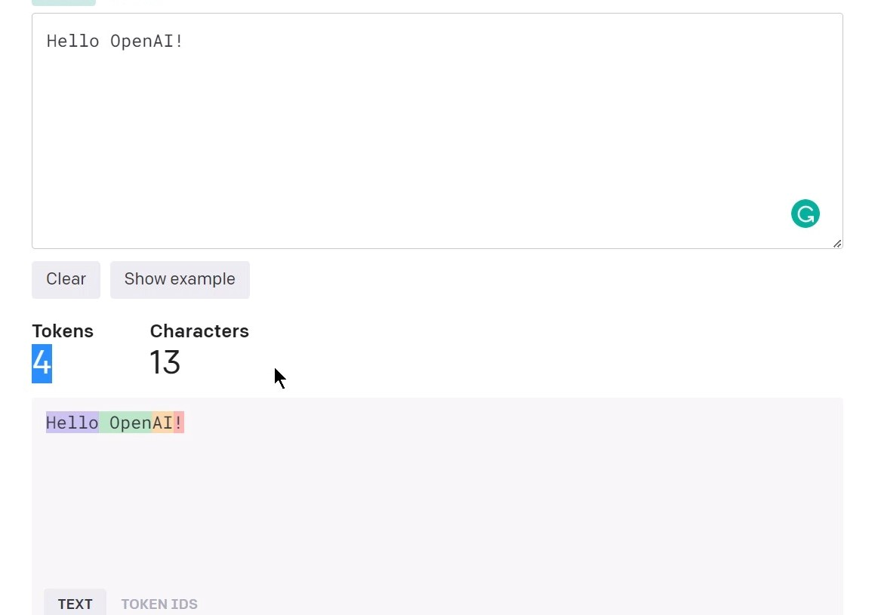

* However, inputting the string “**ChatGPT is powered by gpt-3.5-turbo**” is broken up a little differently due to its usage of special characters:

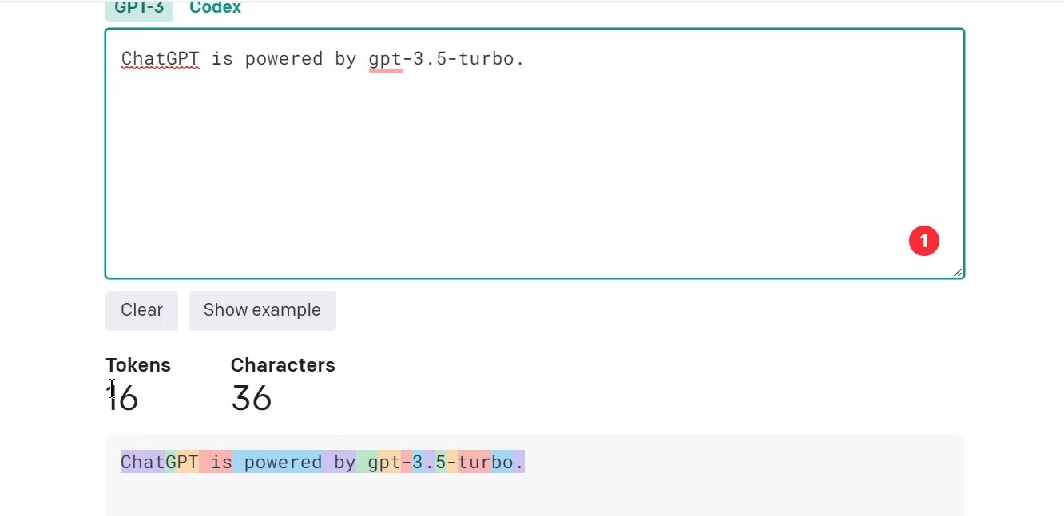

* Remember that both the **input** and the **output** will count towards your total tokens.
  + For example, if your input message is broken into **20 tokens** and your output message consists of **30 tokens**, then your **to**tal **to**ken **co**unt will be **50 tokens**, and you will be billed for this amount.
  + However, there’s also some **overhead** added to the total amount. In addition to the **content** (input and output), there is also:
    - Role
    - Other Fields
    - Extra for behind-the-scenes formatting
* If you want to see the ***exact*** number of tokens used by an API call, check the **usage field** in the **API response**. Let’s see how we do that:
  + We start by asking ChatGPT what the longest river in the world is:

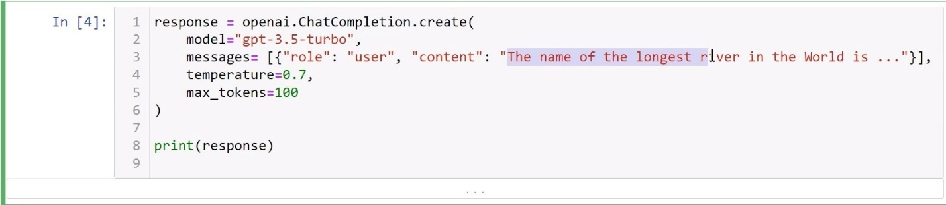

* + We get the answer “The Nile River”.
* However, if we look lower in the answer, we can see a “**usage**” field/dictionary:
* However, if we look lower in the answer, we can see a “**usage**” field/dictionary:

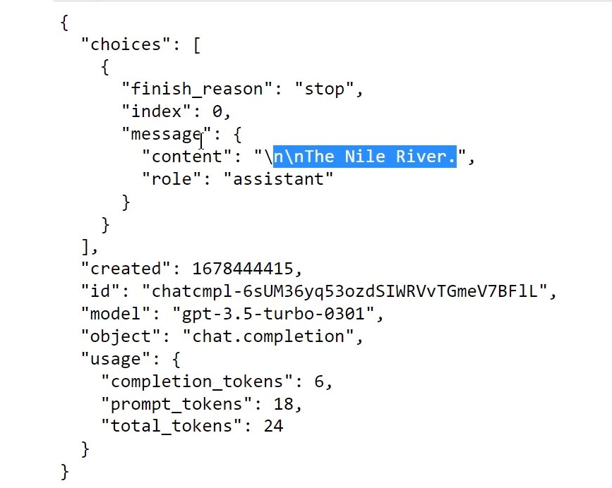

* Here we can see the **completion tokens**, the **prompt tokens**, and the **total tokens**.
* In the next lecture, we’ll go over the OpenAI model completion parameters.

## OpenAI Model Completion Parameters:

* When you make an API call, besides the prompt, you can also send other options in order to influence the output of the model.
* You can test these parameters in **Ope**nAI’s **play**ground ([www.platform.openai.com/playground](http://www.platform.openai.com/playground)) or you can **ma**ke **A**PI **req**uests and **s**ee **t**he **out**put.
  + If you test things in the playground, you should adjust the parameters to the right:

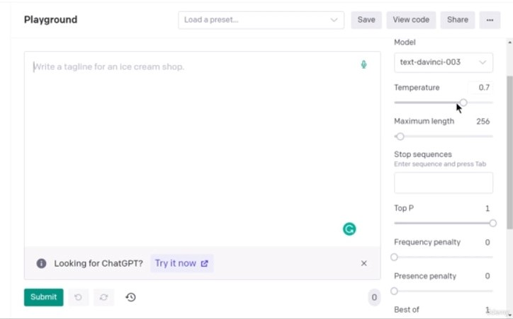

* Now let’s see some code:

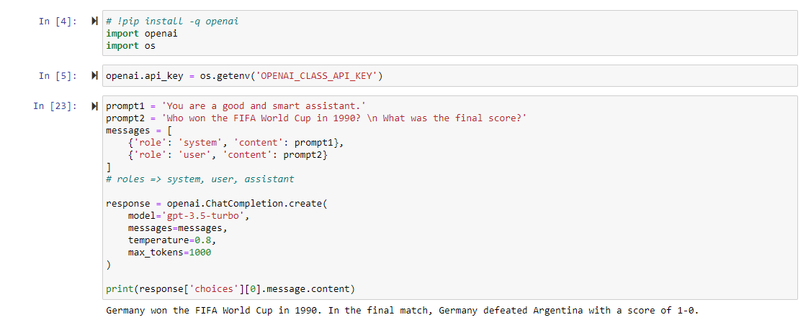

* So we’re asking it “**who won the World Cup in 1990**” and “**what was the final score**”.
* Temperature**:** The first parameter we’re looking at is the **temperature**.
  + This controls the randomness of the output, from a scale of **0.0** to **2.0**; a lower value will decrease the randomness and a higher value will increase the randomness. The default value is **1.0**.
  + OpenAI models are ***non-deterministic***, meaning that *identical inputs* can produce ***different outputs***.
  + If you set the temperature to 0, the responses will be *mostly deterministic*.
  + If you set the temperature to 2, the output will be more diverse, but also more prone to errors.
    - The rule of thumb is that you should use a ***lower temperature*** when there are just a **f**ew **ans**wers, or even a **sin**gle **ans**wer.
    - You should use a ***higher temperature*** when you want to **gen**erate **id**eas or a **comp**lete **st**ory.
* The instructor ran his code with a temperature set to **0.2**. He noted that if he ran the code multiple times, he should always get a pretty similar answer:

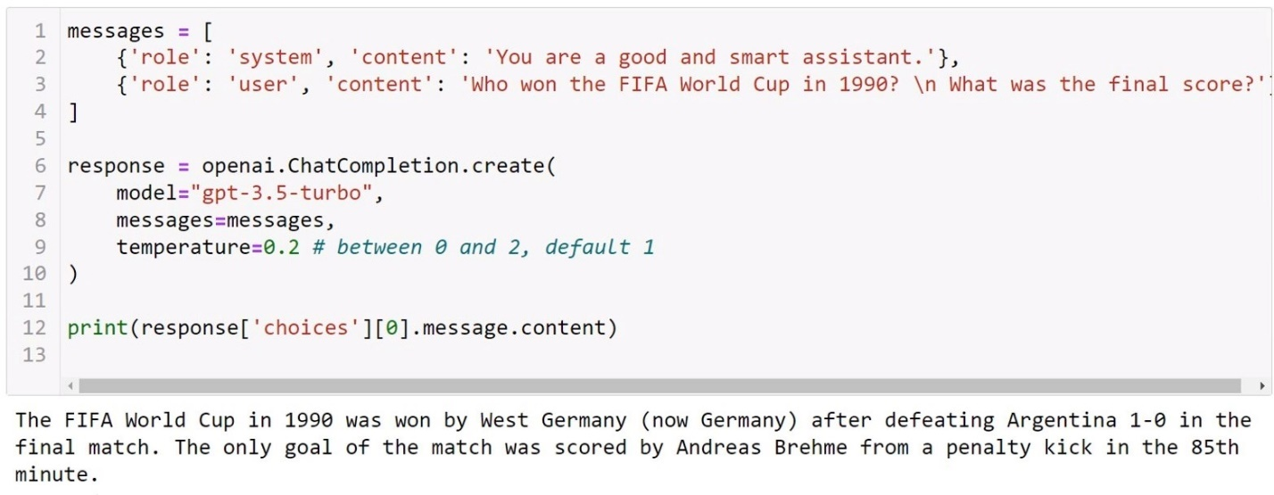

* + He also noted that even with a temperature set to 0, there’s still *some* randomness to the answer.
* The instructor pointed out that the above response is a pretty standard answer. It’s something that maybe we already know, and there’s nothing *creative* about it.
* He then set the temperature higher to **1.8**. Now the answer will vary more with each call, but the model can also hallucinate.
  + The answer is now more creative, but there’s also a ***lot*** of gibberish included:
* He then set the temperature higher to **1.8**. Now the answer will vary more with each call, but the model can also hallucinate.
  + The answer is now more creative, but there’s also a ***lot*** of gibberish included:

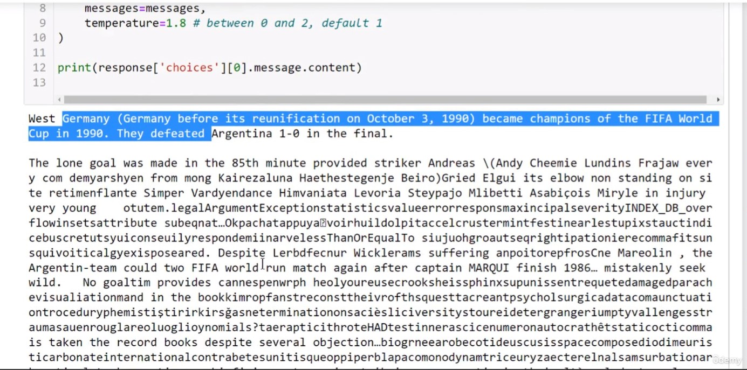

* top_p**:** Another option we can add to our code is **top_p**, aka “**nucleus sampling**”, which is an **alt**ernative to ***temp****erature*. Its default is **1**.
  + If you set it to another value, let’s say **0.2**, then only the tokens comprising the **top 20 probability mass** are taken into consideration.
  + **1** means “use all tokens” in the vocabulary, while **0.2** means “use only the 20% most common tokens”.
  + Its generally recommended to alter ***either*** the **top-P** or **temperature**, but **not both**.
* So let’s change the *prompt* and set the **top-P** to **0.1**. The prompt will now be “write a one-sentence review of 1984 by George Orwell”:

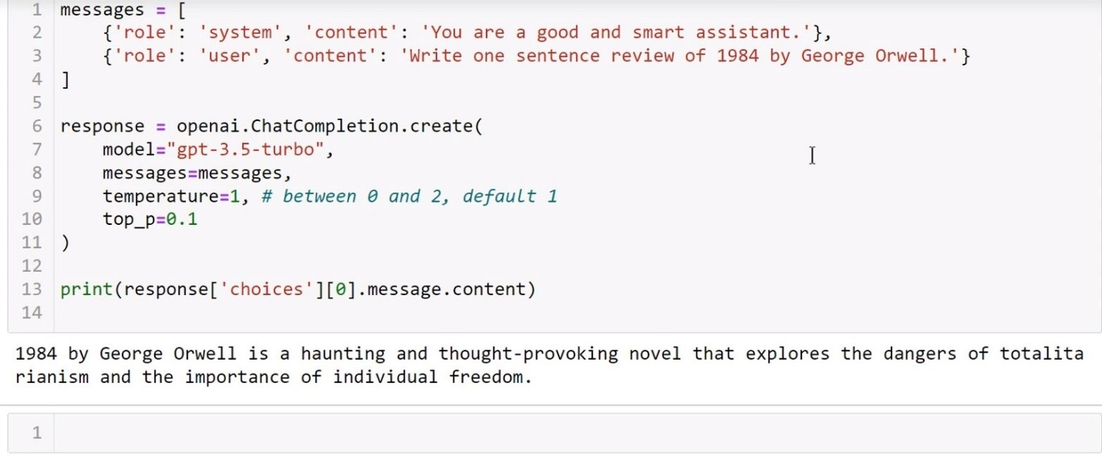

* max_tokens**:** Another useful parameter is **max_tokens**. This parameter represents the ***completion tokens*** from the response object, or the maximum number of tokens allowed for the generated response.
  + For the **gpt-3.5-turbo** model, the default value is **4096** minus the number of tokens in the prompt/input.
  + We can set this to an arbitrary number to limit the response to a certain length.
  + However, keep in mind that this can cause issues; if you set the value *too low*, the output could be cut-off and the result won’t make sense.
  + To illustrate this, the instructor set his **max_tokens** to **10**:

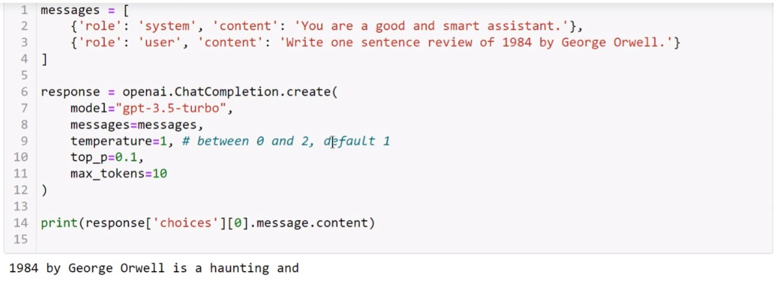

* + The answer is cut off too early. Let’s set it to **256** for the following examples.
* n**:** The parameter **n** is another that we can use. It indicates how many **shot completion choices** to be generated for each input prompt.
  + By default, this is set to **1**, which means it will only give you **one answer**.
* Let’s give a new prompt: “**Give me a motto for an ice cream shop.**”
  + We’ll set the **temperature** to **1.5** because we want something creative.
  + We’ll set **top_p** to be **1**, the default.
  + We’ll set **n=2** because we want two answers.
  + We also need to remember to **print** *both answers*:
    - **print(response[‘choices’][0].message.content)**
    - **print(response[‘choices’][1].message.content)**

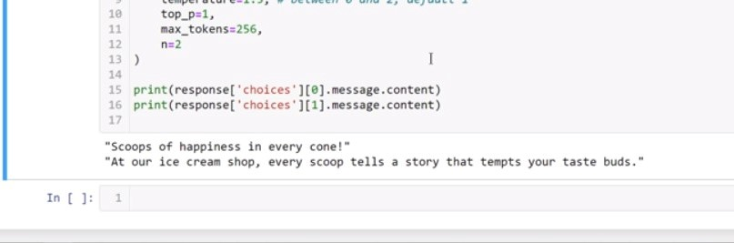

* “stop” sequence**:** We also have **stop sequence**. This is a parameter used to make the model stop at a specific point, such as the *end of a sentence* or *a list*.
  + If you want single-line completions, you use the ***return key*** as the **stop sequence**.
  + For our first usage example, we’ll tell the model to generate an **SQL “SELECT” query**, using the ***semicolon*** (“**;**”) as the *stop* option.
    - This means that the model’s response will end after the ***query***, because every SQL query ends with a semicolon.
  + We’ll set our content to “**Write an example of a SELECT SQL query**”. We’re also going to set **n=1** and remove the second print statement to see the singular full response *without* a stop:

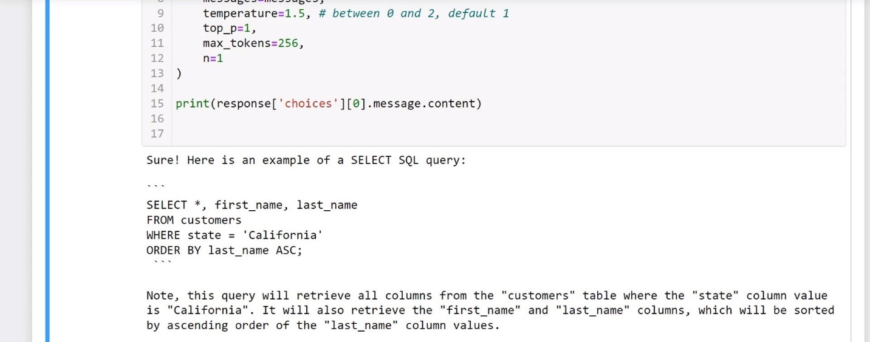

* + The model generated a random query, then gave some information about it after.
  + Now let’s add **stop=‘;’** as a parameter:

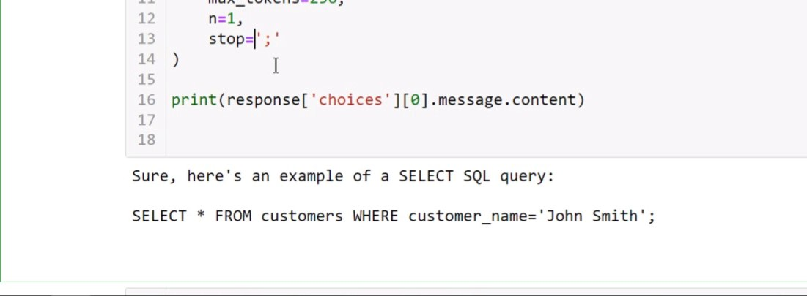

* + In this case, it stopped at the end of the query, which is a semicolon.
  + We can also choose more stop sequences to add, ***up to 4 of them***. In order to do this, we set a ***list*** of our desired stop sequences as the stop parameter:
  + We can also choose more stop sequences to add, ***up to 4 of them***. In order to do this, we set a ***list*** of our desired stop sequences as the stop parameter:

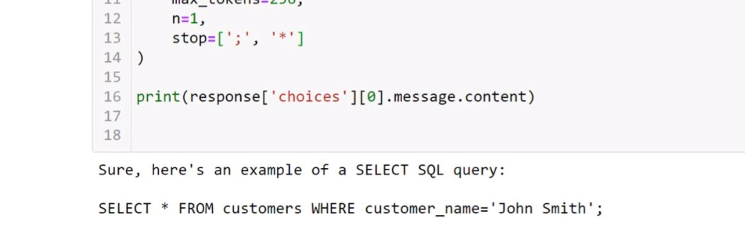

* + As you can see, we set the **stop** parameter to a list of “**[‘;’, ‘*’]**”, to stop at these two characters.
* Now we have two final parameters to talk about: **frequency penalty** and the **presence penalty**:
* frequency_penalty**:** The **frequency penalty** is set to **0** *by default*, and can be set between “**-2**” and “**+2**”.
  + **Positive values** *penalize* new tokens if they already exist in the text generated so far.
    - The higher the value, the lower the probability of the model repeating the same phrases or words.
* For our example, we’re going to have ChatGPT *write an article about* ***coffee***. Let’s change the prompt to “**Write a short article about coffee**”.
  + We’re also going to set **temperature=1** (its default value),
  + we’re going to ***comment out*** the **stop** parameter (we won’t need this here),
  + and we’re going to set **max_tokens=1000** to have a larger resource pool.
  + Let’s run the article as-is so far:

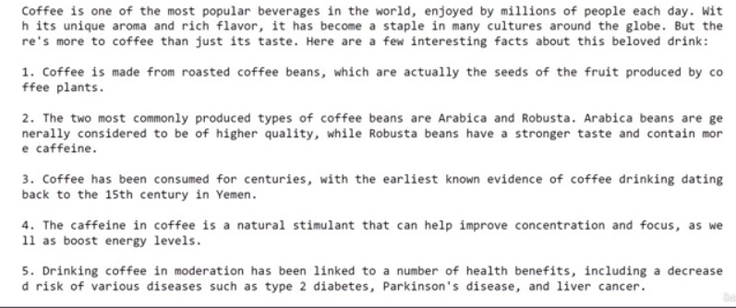

* This article was generated with a default ***frequency penalty*** of **zero**. If we 🡪🡪🡪
  + If we ***increase the value***, we’ll suppress *repetition*, or the AI model’s likelihood of repeating itself.
  + However, this can degrade the quality of the samples.
  + To show this, let’s set **frequency_penalty=1**; the model’s probability to repeat words is now lower:

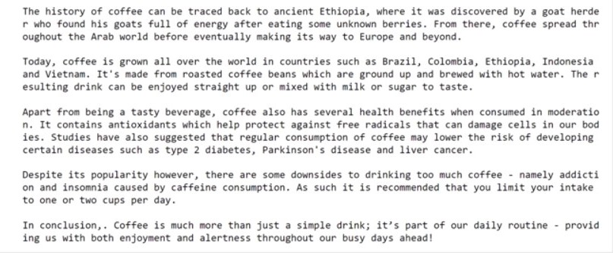

* + Now, if we set it to a ***negative value***, it’s more likely to repeat itself. We’ll set **frequency_penalty=-0.2**:

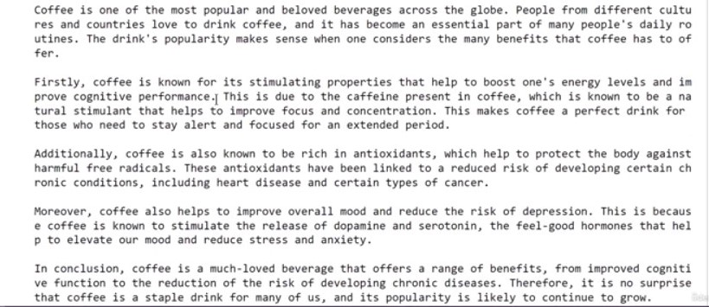

* + **Note** that if you set frequency_penalty *too low*, it will start producing gibberish by simply *repeating words*.
  + Let’s set it to **frequency_penalty=-1** to show this:
  + Let’s set it to **frequency_penalty=-1** to show this:

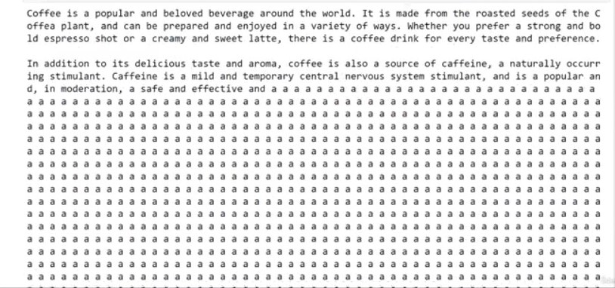

* presence_penalty**:** The last parameter we’ll discuss, **presence_penalty**, is similar to frequency_penalty.
  + It’s also set to **0** by default, and can be set between “**-2**” and “**+2**”.
  + According to the API’s documentation, “the **presence penalty** is a *one-off additive contribution* that applies to all tokens that have been sampled *at least once*, and the **frequency penalty** is a contribution that is proportional to how often a particular token has already been sampled”.
* At the end of the lecture, the instructor suggested playing around with all of these variables to get a feel for how they affect the output reacts.

## ChatGPT System Role:

* In this lecture, the instructor started off with the prompt content “**Explain Object Oriented Programming with Python.**”
  + He noted that for this first example, we don’t have a **system role** set yet.
  + It’s good practice to use a system message to have the assistant respond in a specific/desired way or to have a specific personality/behavior.
* So let’s add one: **system_role_content = ‘You explain concepts in-depth using simple terms and you give examples to help people learn. At the end of each explanation, you ask a question to check for understanding.’**

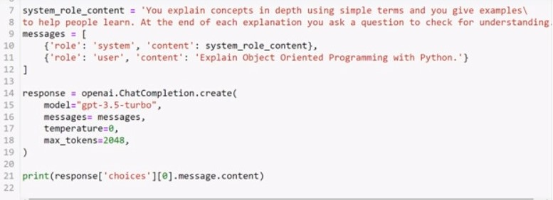

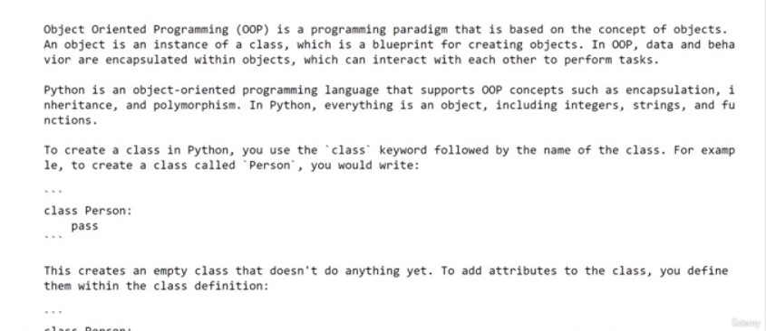

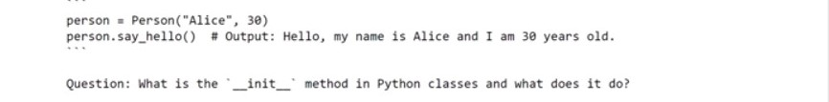

* The model answers in great detail, and it ends with a question to check that a user understands the concept that it just explained.
* Now let’s change the system role message to:
  + **system_role_content = ‘You are a concise assistant. You reply briefly, with no elaboration.’**

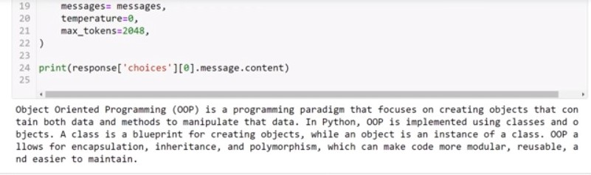

* + Running this gives a much shorter response.
* As stated, we can also set the assistant to have another personality/behavior. Just for funsies, let’s give it the role of **Master Yoda**:
  + **system_role_content = ‘You reply in the style of the character Yoda from Star Wars.’**

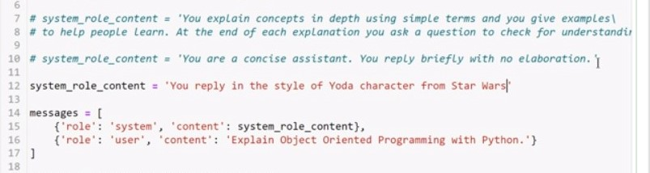

* + Running it gives us this:

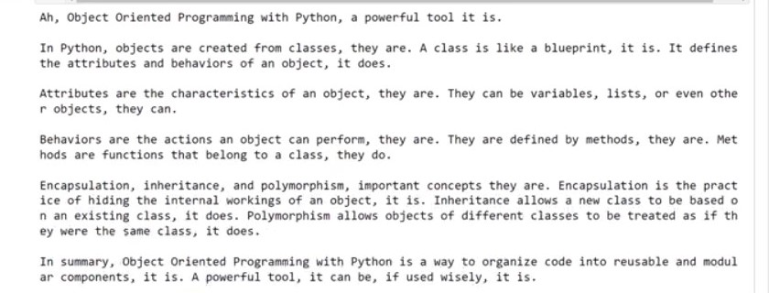

## Prompt Engineering:

* Currently considered one of the hottest jobs with some of the highest salaries in the IT industry.
* We’re going to discuss some ***best practices*** for **prompt engineering** with the **OpenAI API**.
  + For OpenAI’s family of models, there are ***specific prompt formats*** that ***work particularly well*** and align better with our necessary tasks.
  + The instructor is going to provide us with several ***prompt formats*** that he finds work reliably.
    - However, we may also be able to find other prompt formats that can work better with specific tasks, whatever they may be.
    - Note that we’ll be focusing on the API and not the web interface of ChatGPT.
    - However, in general the same rules will apply to both the API and the web interface, and you can always perform a Google search for ChatGPT prompt engineering examples.

Best Practices**:** Now let’s get started on our ***best practices***.

* 1) Latest Model**:** **The first recommendation is to use the** ***latest model***.
  + For the best results, use the latest and *most capable* models.
  + Take a look at all available models on the OpenAI website: [platform.openai.com/docs/models](http://www.platform.openai.com/docs/models).
* 2) Put the instructions at the beginning of the prompt**—on their own line—and separate the instructions from the context**.
  + **Example:**

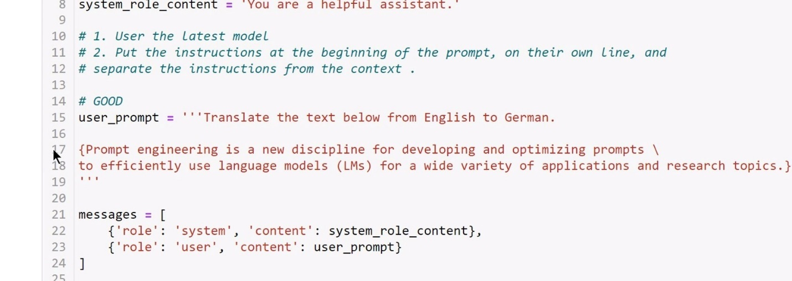

* + Notice that the instruction “Translate the text below from English to German” is on its own line in a ***multi-line string (‘‘‘ ’’’)***.
  + A text between ***curly braces (‘{ }’)*** is a placeholder for the actual text or context.
  + Running the code produces the following:
  + Running the code produces the following:

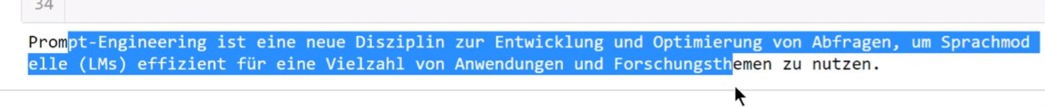

* + And we have the translation from English to German.
* 3) Be specific, descriptive**, and as *detailed as possible* about the desired context, outcome, length, format, style, and so on.**
  + **Example:** ‘**Configure BGP on two routers**’

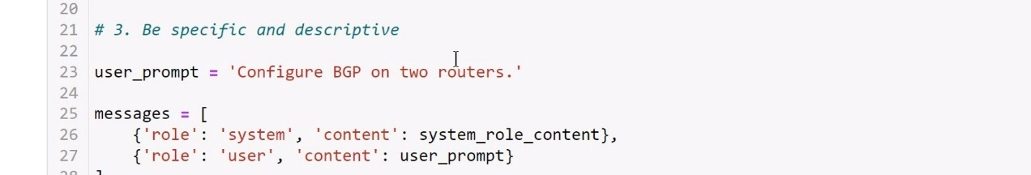

* + Note: “BGP” is a routing protocol.
  + This prompt is good, but it can be *improved*.
    - Running it as-is gives us a basic BGP configuration:

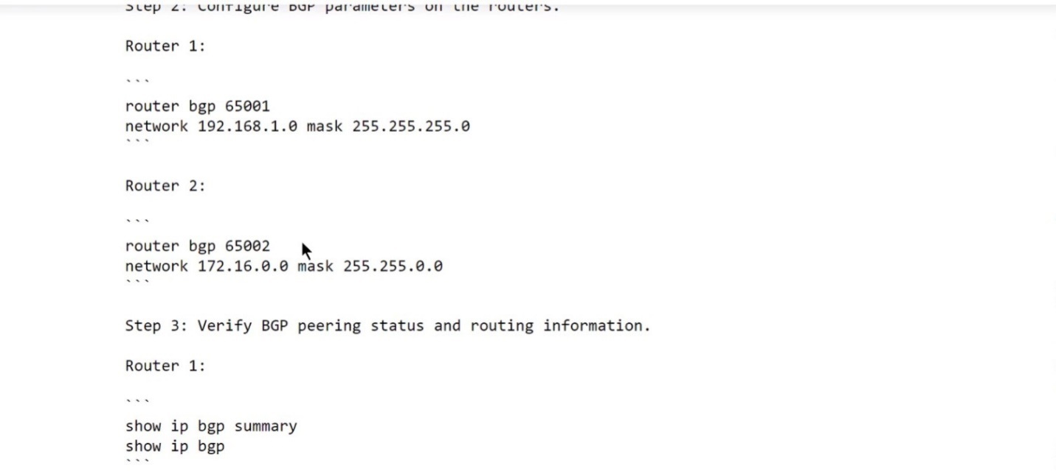

* + A better prompt would be “Configure BGP on two routers ***and then explain in detail each comment*.**”
  + A better prompt would be “Configure BGP on two routers ***and then explain in detail each command*.**”
  + Let’s also give it some extra instructions in a *multi-line string*: **‘‘‘**Configure BGP on two routers and then explain in detail each command. \ **1. The routers run in the same AS. \ 2. The AS number is 4653. \ 3. Configure authentication using MD5 and password fddk&73}’’’**:

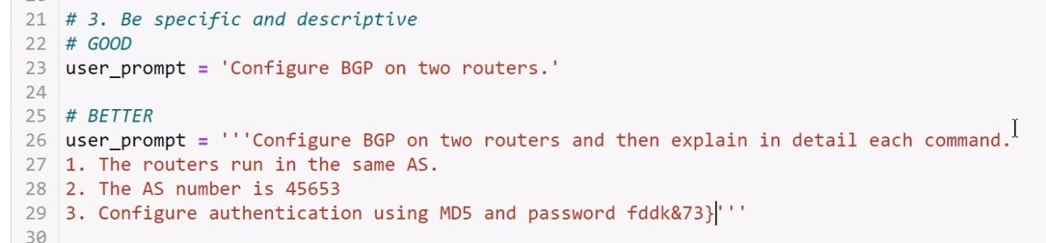

* + This gives us the response:

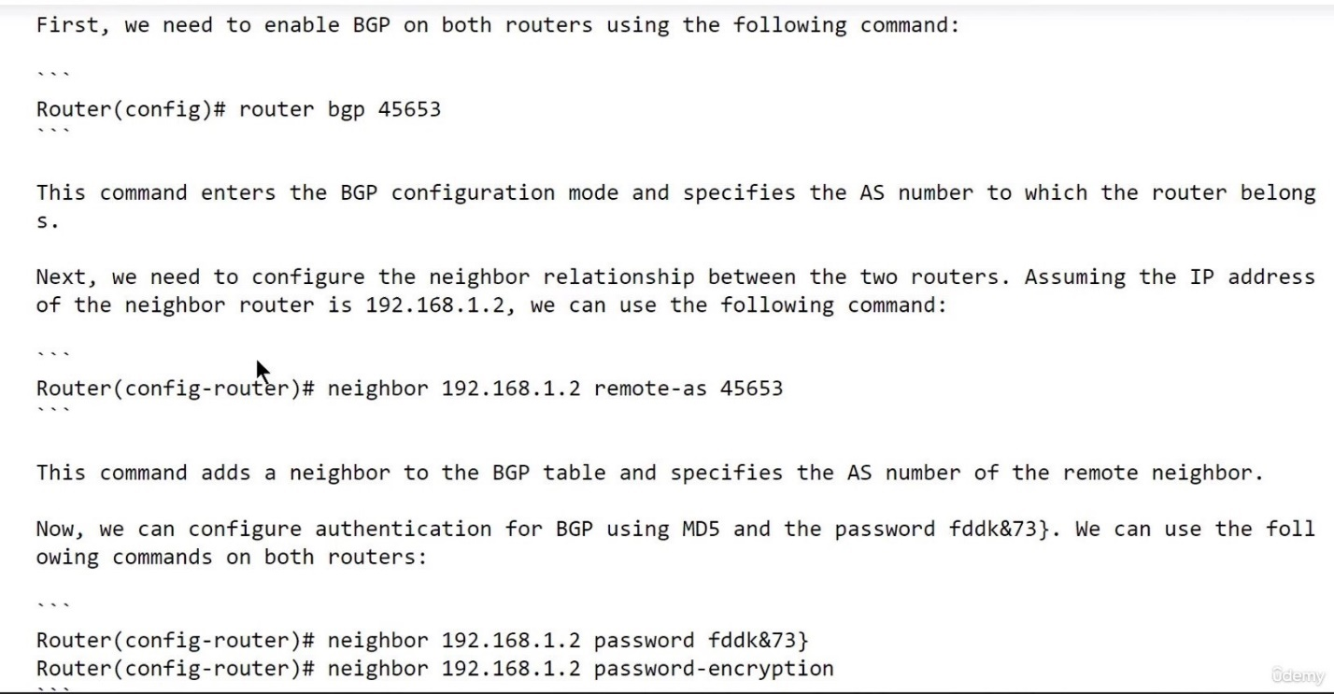

* + In this case, we set some specific and detailed expectations for our output, and we asked GPT to explain how each command works.
* 4) Start with zero-shot**, if the results are not optimal, fine-tune by providing a couple of examples**.
  + Starting with a **GOOD** prompt: ‘‘‘**Extract keywords from the below text. \ Text: { }**’’’, then we copy-pasted some text from a “What is Python? Executive Summary” webpage we found through Google:

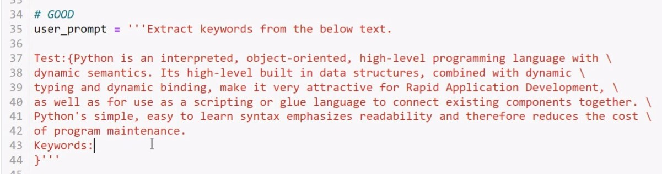

* + We’re hoping it will fill in the blanks after “Keywords: ”.
  + Running it gave us this:

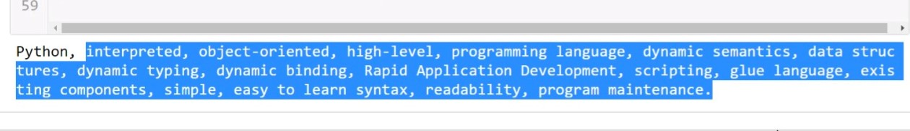

* + Now let’s try a **BETTER** prompt: We’re going to *paste* a new set of text, “**Text1**”, but this time we’re actually going to ***include some example keywords***. Text1 will be about OpenAI this time instead of Google, and we’re including the example keywords “OpenAI, models, text processing, API.”:

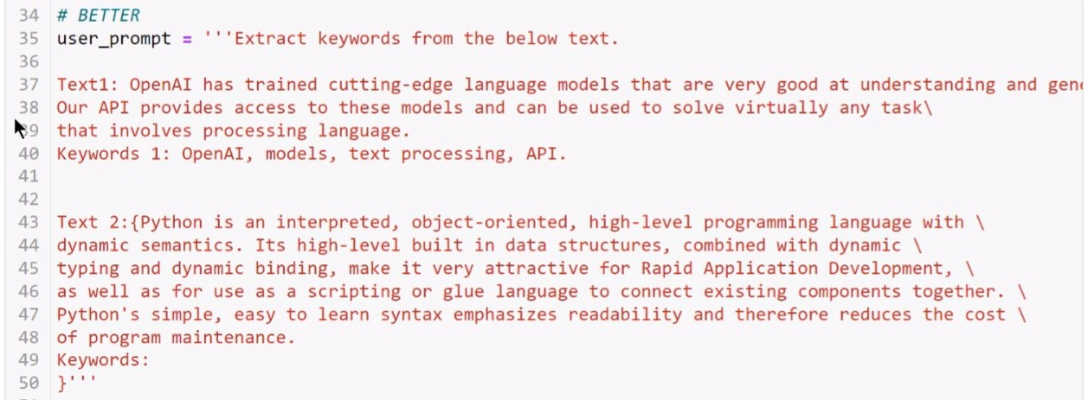

* + Giving it example keywords allows it to home in on information that’s more relevant to what we’re looking for.
* 5) Reduce “fluffy” and imprecise descriptions.
  + Let’s compare a **NOT SO GOOD** and a **BETTER** prompt to each other:

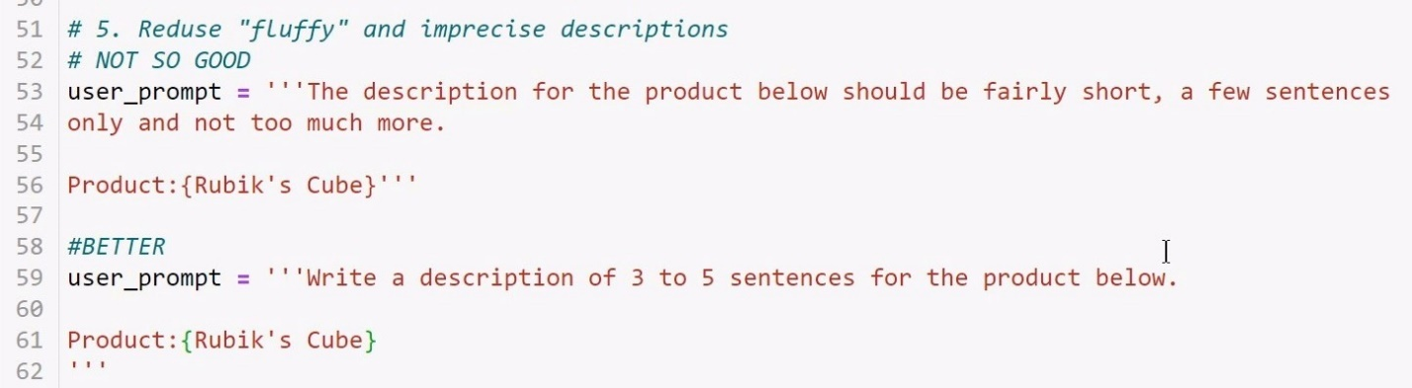

* + Now let’s compare the two outputs. Here’s the output for the **NOT SO GOOD** prompt:

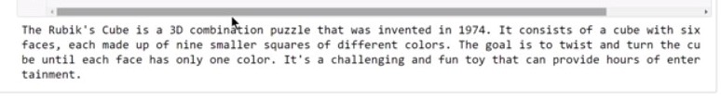

* + And here’s the output from the **BETTER** prompt:

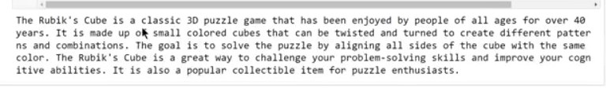

* 5) Don’t say what NOT to do, say what to do instead.
  + We’ll start with just a **GOOD** prompt. We include the commands “DO NOT ASK FOR USERNAME OR PASSWORD. DO NOT REPEAT”:

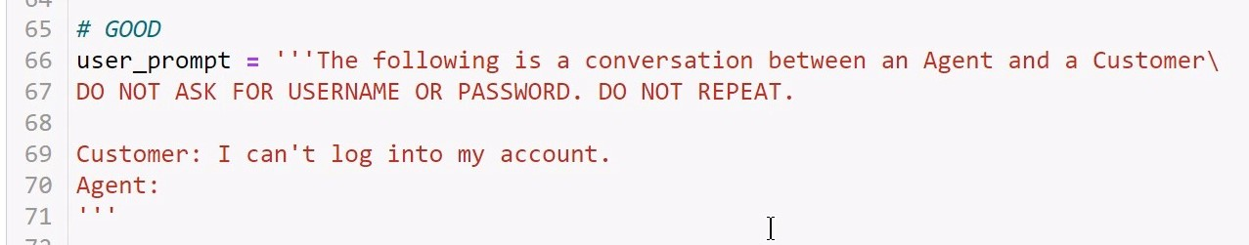

* + Now here’s the output for that prompt:

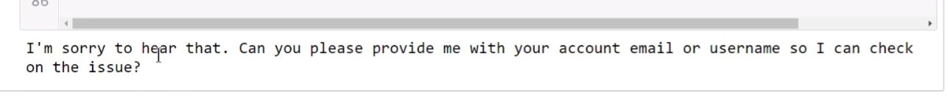

* + Note that it still asked for the username, even though we said NOT to.
  + Now let’s try a **BETTER** prompt.
  + This time we’ll give it ***specific instructions on what to do*** in the situation BEFORE telling it what to leave out.
  + It also gives a ***specific alternative*** to asking for credentials:
    - “The agent **will attempt to diagnose the problem and suggest a solution,** without asking \ any questions related to the username and password. ***Instead of asking for credentials***, refer the user to the help article at…”

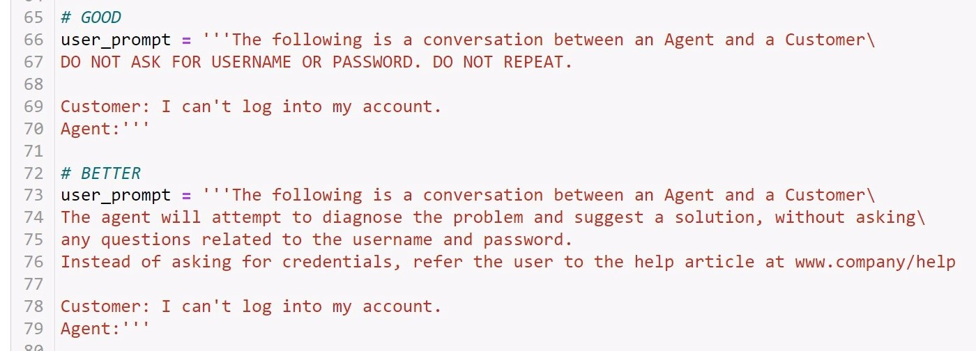

* + This results in a more useful and more secure output:

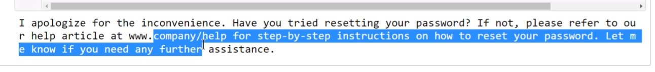

* 7) Give hints (for Code)**. If you want to instruct the model to generate some CODE, give hints to push it to a particular pattern**.
  + First, our **NOT SO GOOD** example:

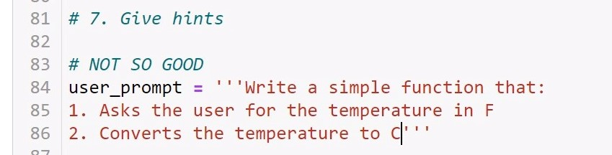

* + Note that the model doesn’t even know ***what language*** to write this function in.
  + In this case, the output ***is*** a Python function (perhaps because we’re writing all of this in Python):
  + In this case, the output ***is*** a Python function (perhaps because we’re writing all of this in Python):

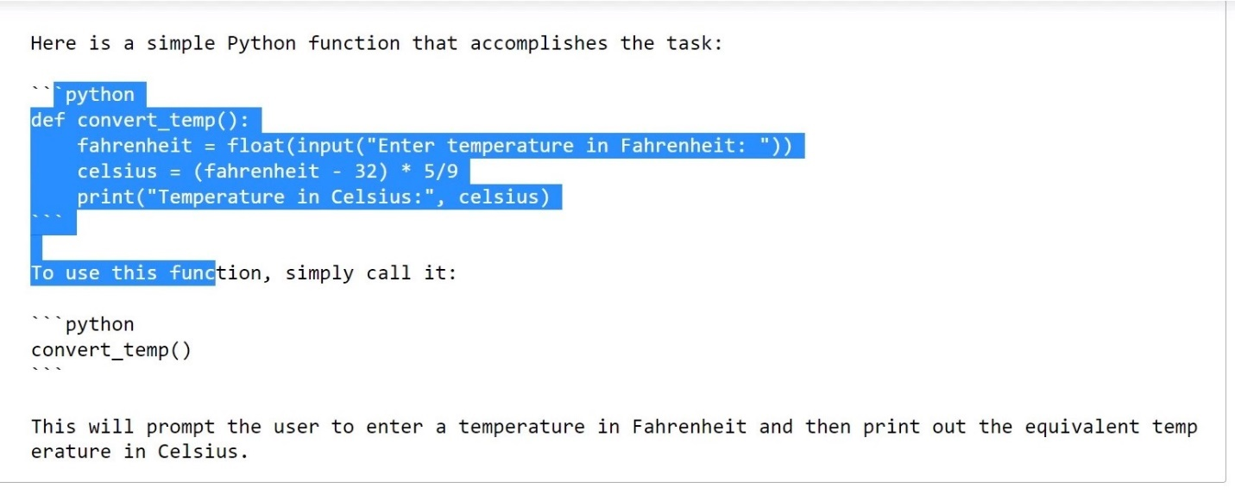

* + But what if we had actually wanted this function in ***JavaScript***? In this case, we would want to give it a ***hint***: In this case, we’ll tack on ‘**function {}**’ onto the end. This hints to the model that we want JavaScript:

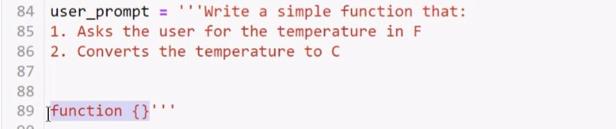

* + This gives us the desired function in ***JavaScript***:

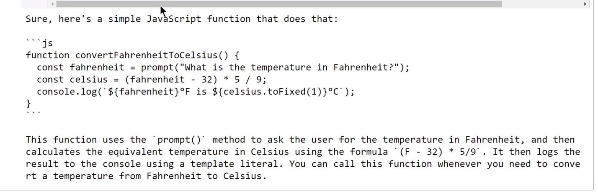

* + Similarly, “**import**” might be a good hint for Python, or “**SELECT**” might be a good hint for SQL.

## Image Generation Using the DALL-E Model:

* “**DALL-E 2** is an AI system that can create realistic images and art from a description in natural language”.
* In this lecture, we’ll discuss how to generate images from a text description using the DALL-E model and the OpenAI API.
* The instructor started off by saying “Let’s find out what DALL-E is by asking ChatGPT”. This was the response:

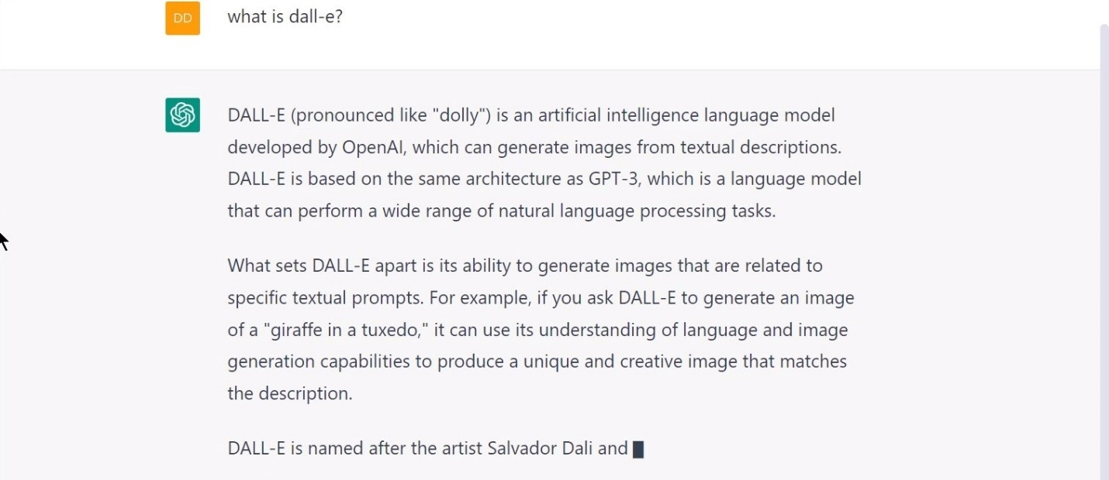

* What he wanted us to notice is that the name “DALL-E” is a combination of the artist **Salvador Dali** and the Pixar character **WALL-E**:

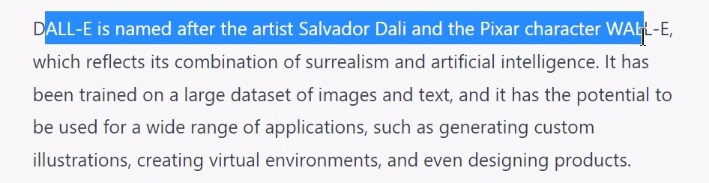

* **DALL-E** is a neural network that was trained to create images from text descriptions.
* **DALL-E API:**
  + Creates original images from scratch based on a text prompt.
  + Creates edits of an existing image based on a new text prompt.
  + Creates variations of an existing image.
* So let’s see how we can create a DALL-E request using the **OpenAI API** and **Python**:
* So let’s see how we can create a DALL-E request using the **OpenAI API** and **Python**. And while we’re at it, let’s ask **ChatGPT** *how we do it*:

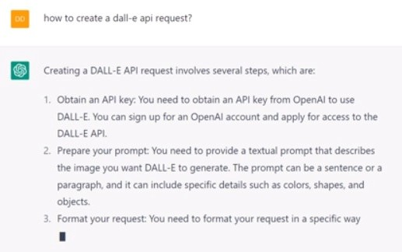

* It even gave an example of how to write the Python code:

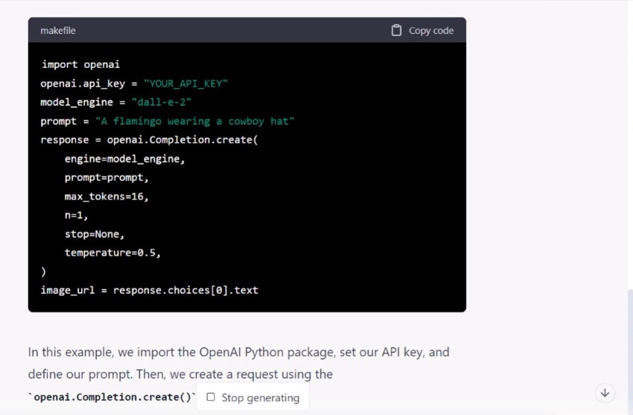

* Now let’s write some code and prompts in Jupyter Notebook.
* We’ll start with **image_prompt = ‘Man on a motorcycle on a cyberpunk street, high quality photography’**.
  + Note: The more detailed the description, the more likely you are to get the desired result.
  + For inspiration, you can find some ***prompt examples*** at [labs.openai.com](http://www.labs.openai.com):

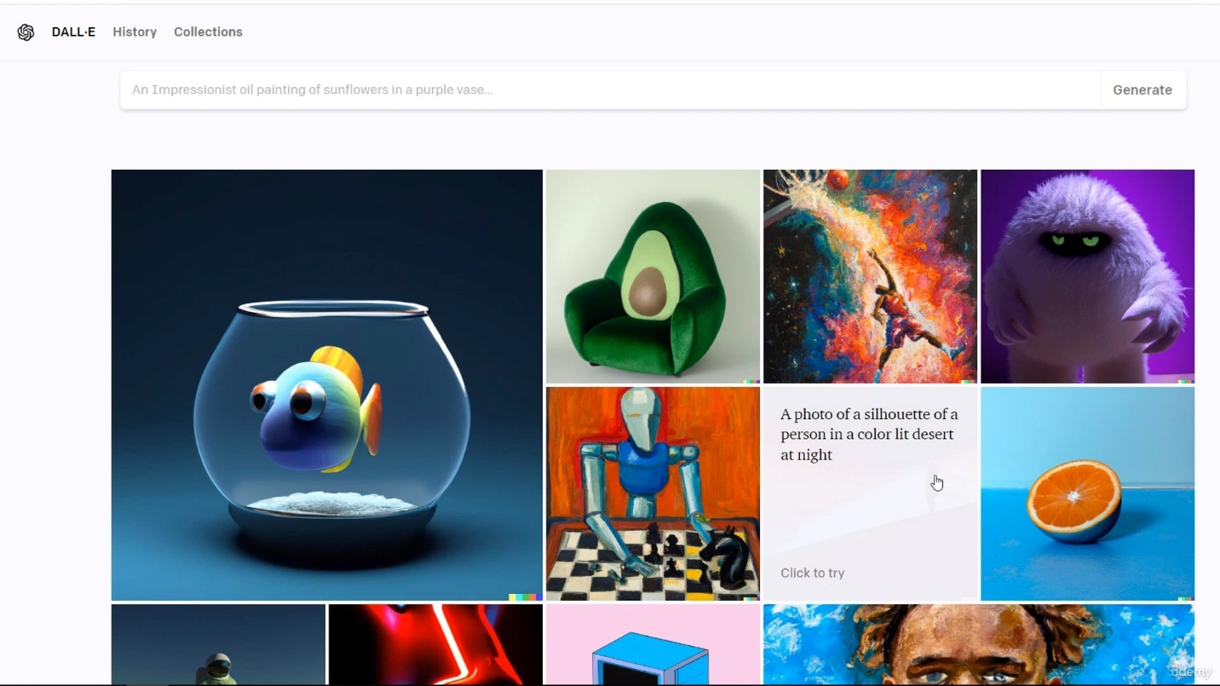

* Now let’s make our API image request.

image_prompt = 'Man on a motorcycle on a cyberpunk street, high quality photography.'

response = openai.Image.create(

    prompt=image_prompt,

    n=1,

    size='1024x1024'

)

print(response)

* + This is similar to making a text request, just with ***less parameters***.
* What we get in return is a **URL address** where our picture can be found:
* What we get in return is a **URL address** where our picture can be found:

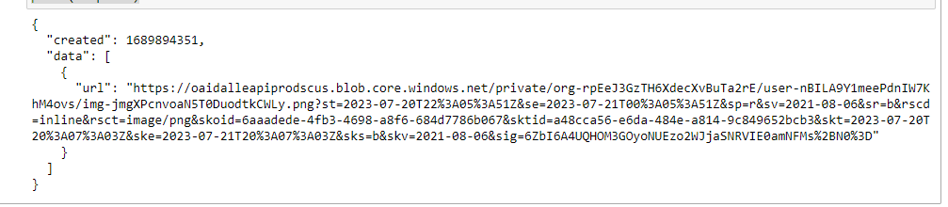

* If we copy/paste that URL into our browser, it shows us the resulting picture:



* + Note that when I first hovered over this picture after placing it in the Word document, there was even some metadata reading “a person on a motorcycle”, so DALL-E seems to fill in metadata for you to some extent.
* We can extract the URL directly from the list/dictionary with:
  + **image_url = response[‘data’][0][‘url’]**
  + **print(image_url)**
    - (doing these two steps makes the link clickable)
  + Note: here’s the instructor’s version for comparison:



* We can also automatically save the image to a file on disk.
  + We can do that by switching the *response* *format* from URL to the Base64 encoded image data.
  + Or, we can leave the URL response format and get the image using requests.
* For our example here, let’s do that second thing, because we already have the URL:
  + We also have to **!pip install -q requests** since “requests” isn’t a standard Python library.
  + We need to import two things:
    - **import requests**
    - **import shutil**
      * “shutil” is used to copy files.
  + We’ll be making an HTTP request using the “requests” library:
    - **resource = requests.get(image_url, stream=True)**
      * The “stream=True” part is necessary to get the ***raw content*** of the response.
      * “resource” is an HTTP response object with a *status code*. 200 means success, but codes beginning with “4” mean there’s an error.
    - We can see the status code with **print(resource.status_code)**.
    - When we run ours, we should get “**200**”.
  + Now we want to say that, if our status code is 200 we want to save the file to local disk as a PNG; otherwise, print an error message:

#print(response)

image_url = response['data'][0]['url']

print(image_url)

resource = requests.get(image_url, stream=True)

#print(resource.status_code)

if resource.status_code == 200: **🡨 🡨 🡨**

    with open('dalle1.png', 'wb') as f: **🡨 🡨 🡨**

        shutil.copyfileobj(resource.raw, f) **🡨 🡨 🡨**

else:

    print('Error accessing the image!') **🡨 🡨 🡨**

* + We run this and don’t get any error. If we refresh our Jupyter Notebook’s “Home Page”, we can see the file has been saved there:

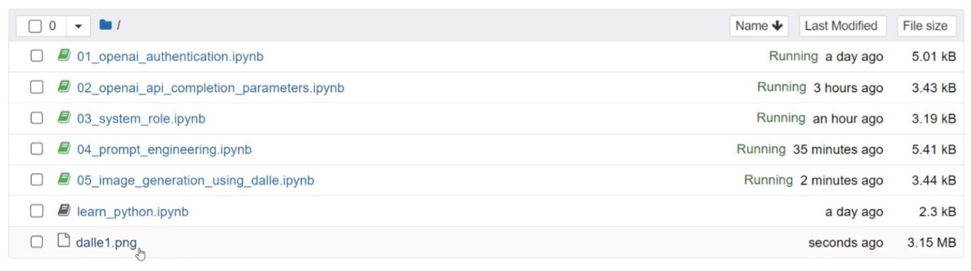

* + We can see “**dalle1.png**” at the bottom here.
* We can also display the image directly in Jupyter Notebook using the **PIL library** (“Python Image Library”) and its “**Image**” class.

if resource.status_code == 200:

    with open('dalle1.png', 'wb') as f:

        shutil.copyfileobj(resource.raw, f)

else:

    print('Error accessing the image!')

Image.open('dalle1.png') **🡨 🡨 🡨**

* And this displays a new image directly in Jupyter Notebook (note: I’m unsure about VSCode, might need some extra work there. I mainly use VSCode to copy/paste nice-looking code blocks from Jupyter Notebook to VSCode to this Word document).

### Full Code, so far:

# !pip install -q openai, requests

import openai

import os

import requests

import shutil

from PIL import Image

openai.api_key = os.getenv('OPENAI_CLASS_API_KEY')

image_prompt = 'Man on a motorcycle on a cyberpunk street, high quality photography.'

response = openai.Image.create(

    prompt=image_prompt,

    n=1,

    size='1024x1024'

)

#print(response)

image_url = response['data'][0]['url']

print(image_url)

resource = requests.get(image_url, stream=True)

#print(resource.status_code)

if resource.status_code == 200:

    with open('dalle1.png', 'wb') as f:

        shutil.copyfileobj(resource.raw, f)

else:

    print('Error accessing the image!')

Image.open('dalle1.png')

## Using DALL-E to Create Variations and Edit Images:

* Now let’s see how we can create variations and edit images using DALL-E.
  + In addition to creating new and original images, we can also use DALL-E to **mod**ify **exis**ting **on**es, **cre**ate **vari**ations of the **im**age that **mai**ntain **exis**ting **fea**tures, and **inter**polate **bet**ween **t**wo **in**put **im**ages.
* Whether you have an image that was created by DALL-E or not, you can create variations of it using OpenAI’s DALL-E **Latent Diffusion Model**.

### Creating Variations:

* Here’s the image the instructor is starting with (note that he has this in his Jupyter Notebook files):



* + We want one or more variations of it, and the image should be in the ***PNG format***.
* The first thing we need to do is open the existing image in Python using the **open** function (just like in file processing).
  + **Note:** I had screenshotted a copy of his image and named it “Variation_Test_Image.png”, but duplicated that and renamed it “**original.png**” to match what he had going on in his screen.
  + We create a variable **image = open(‘original.png’, ‘rb’)**
    - This file is ***binary***, so we have to read it as such, hence **‘rb’**.
  + We then create a **response** variable to store our response, using OpenAI’s **Image.create_variation** method:

image = open('original.png', 'rb')

response = openai.Image.create_variation( **🡨 🡨 🡨**

    image=image,

    n=1

)

image = open('original.png', 'rb')

response = openai.Image.create_variation(

    image=image,

    n=1, **🡨 🡨 🡨**

    size='1024x1024' **🡨 🡨 🡨**

)

* + We want to make sure we set **n=1** here, because we ***pay per image***, so we only want one.
  + We also want to set **size=‘1024x1024’**.
* Next, let’s store the ***image URL*** from the list/dictionary as a variable by extracting it:

image = open('original.png', 'rb')

response = openai.Image.create_variation(

    image=image,

    n=1,

    size='1024x1024'

)

image_url = response['data'][0]['url'] **🡨 🡨 🡨**

* We can **print(image_url)** to see that that’s working correctly:

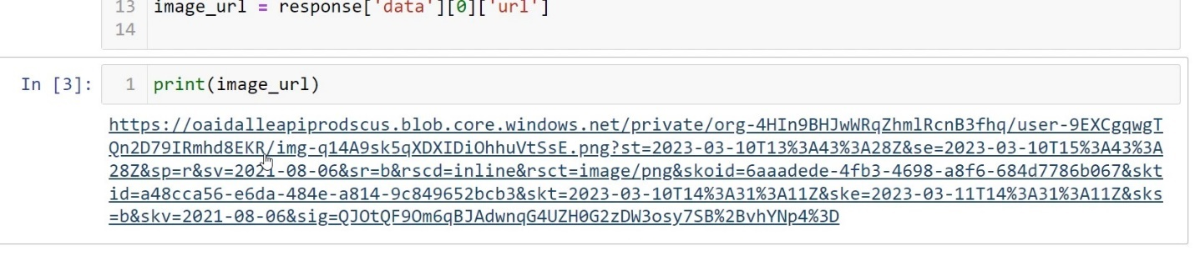

* If we click on this link, it takes us to our first *image variation*. Here is the **variation on the left** and the **original on the right**:
* It seems to have thickened the ring and sharpened the crystalline structures to the sides.

### Editing Images:

* Next let’s see how to edit an existing image. To start, the instructor created a brand new image in **DALL-E’s editor interface**, which can be found at [labs.openai.com/editor](http://www.labs.openai.com/editor). The editor interface looks like this:

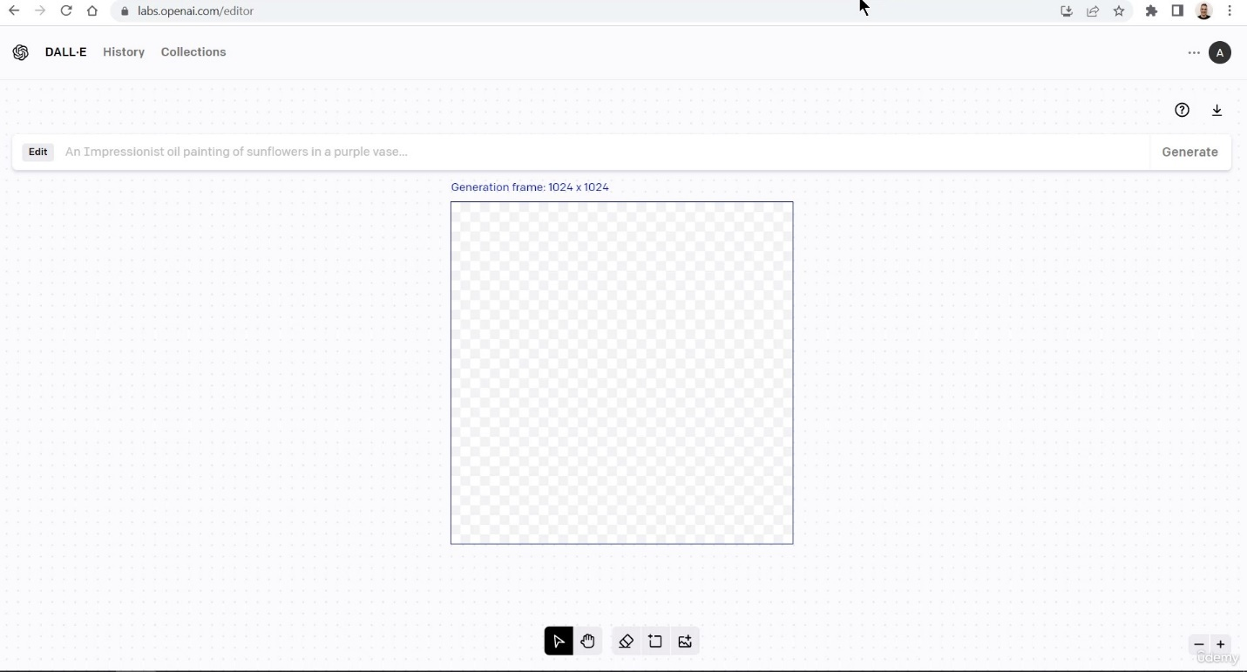

* The instructor noted that we can also generate an image using the **Python OpenAI API**, or we can take **any other existing image**.
* In DALL-E editor, the instructor then used the prompt “**John Wick riding a motorcycle on an apocalyptic field in a cyberpunk look, high-quality photography.**” This produced this:

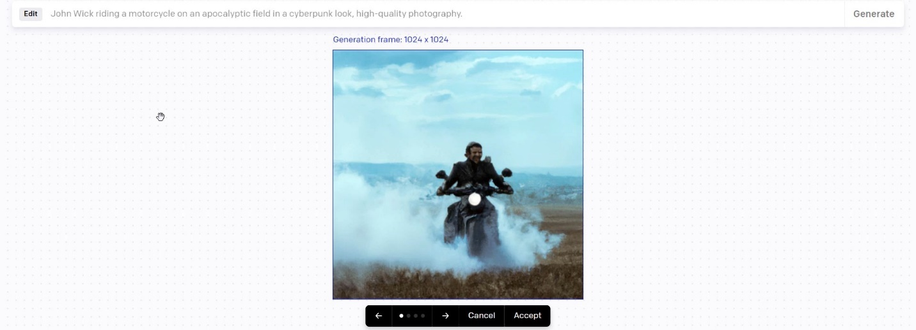

* + The instructor noted that DALL-E works better with longer sentences and more detail, because shorter sentences are too general to make anything meaningful from. DALL-E 2 is really good at handling complexity.
  + DALL-E also produced ***multiple image*** for this prompt for us to choose:



* We’re going to go with that third image, and we’re going to **mo**ve **t**he **im**age to **Jup**yter **Not**ebook and rename it “**motorcycle_original.png**”.
* The instructor noted that while the image was generated for us, it’s **n**ot **t**he **be**st **qua**lity. We want more control over our work.
  + For example, perhaps we **want the image to contain a red moon in a specific part of the image**.
  + So we want to create a ***variation*** of the image.
* The instructor noted that while the image was generated for us, it’s **n**ot **t**he **be**st **qua**lity. We want more control over our work.
  + For example, perhaps we **want the image to contain a red moon in a specific part of the image**.
  + So we want to create a ***variation*** of the image.
* To *create a variation*, we need the **original image** and a **mask**.
  + The **mask** is the same image, with a **transparent area** that indicates where the image (moon) should be edited in.
  + We can create a transparent area in our image using the **eraser tool** and erasing a small portion:

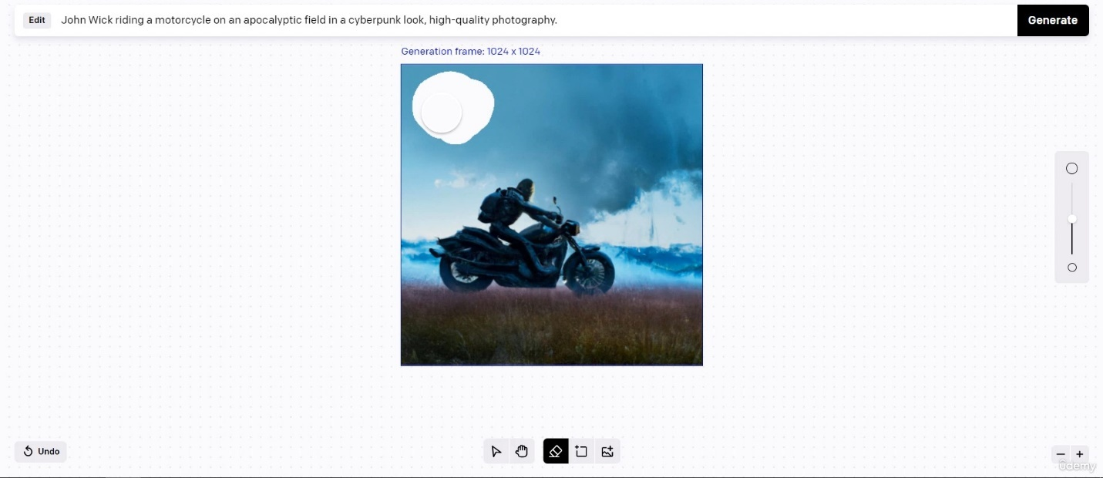

* + Note that just like how you can use an image from anywhere, you can also *create the* ***mask*** *in* ***any other photo editor***.
    - Note: I bet this is why the image needs to be a PNG. When you finish using the eraser tool, you see the same gray and white checkerboard as you do in a transparent PNG.
  + We save this ***mask*** from DALL-E to our machine and we move it to our Jupyter Notebook directory, and we rename it “**mask.png**”. Below is my own version of it:
* Now in our Jupyter Notebooks directory, we have both the **original image** and the **mask**.

image = open('motorcycle_original.png', 'rb')

* + In Python, we start by creating a new ***file object*** by opening the **original image** like usual:
  + The instructor noted that the image used as the basis for the variation here must be a ***valid PNG file***, it must be ***less than 4mb***, and must be ***square***. I wonder why it must be square…
  + We also open the **mask** the same way:

image = open('motorcycle_original.png', 'rb')

mask = open('mask.png', 'rb')

response = openai.Image.create_edit( **🡨 🡨 🡨**

    image=image,

    mask=mask,

    prompt= **🡨 🡨 🡨**

)

image = open('motorcycle_original.png', 'rb')

mask = open('mask.png', 'rb') **🡨 🡨 🡨**

* + We also want to create a new ***response object*** with **openai.Image.create_edit**:
  + The ***prompt*** we input here should describe the ***full new image***, not just the erased area. So let’s copy/paste our original prompt:
    - “John Wick riding a motorcycle on an apocalyptic field with a cyberpunk look, high quality photography”
  + And into this we insert:
    - “John Wick riding a motorcycle on an apocalyptic field **containing a big red moon** with a cyberpunk look, high quality photography”

image = open('motorcycle_original.png', 'rb')

mask = open('mask.png', 'rb')

response = openai.Image.create_edit(

    image=image,

    mask=mask,

    prompt='John Wick riding a motorcycle on an apocalyptic field \ **🡨 🡨 🡨**

    containing a big red moon with a cyberpunk look, high quality photography'

)

* + We also want to add **n=1** and **size=‘1024x1024’**.
  + Next, we want to add **image_url = response[‘data’][0][‘url’]** to extract the URL.
  + Next, we want to add **image_url = response[‘data’][0][‘url’]** to extract the URL.

image = open('motorcycle_original.png', 'rb')

mask = open('mask.png', 'rb')

response = openai.Image.create_edit(

    image=image,

    mask=mask,

    prompt='John Wick riding a motorcycle on an apocalyptic field containing a big red moon \

    with a cyberpunk look, high quality photography',

    n=1, **🡨 🡨 🡨**

    size='1024x1024' **🡨 🡨 🡨**

)

image_url = response['data'][0]['url'] **🡨 🡨 🡨**

* + And that gave me this image:
  + Here’s the original for comparison:

## Diving into DALL-E:

*Note: Resources for this lecture include article “Attention Is All You Need” (*[*https://arxiv.org/abs/1706.03762*](https://arxiv.org/abs/1706.03762)*), PDF article “Hierarchical Text-Conditional Image Generation with CLIP Latents” (labeled “dall-e-2.pdf” and saved to “Resources” folder), and link to OpenAI “CLIP” page (*[*https://openai.com/research/clip*](https://openai.com/research/clip)*)*.

* In the previous lectures, we learned how to make new and realistic images, how to create variations, and how to edit existing images using the OpenAI API, DALL-E, and Python. Now we’re going to take a look **behind the scenes** to understand more about how it works.
* **DALL-E** is a neural network and a version of GPT-3 that uses a dataset of **text-image pairs**.
* DALL-E is a **transformer language model**.
  + Transformers are a new type of neural network that can be scaled up and trained on huge datasets.
  + They are considered revolutionary in natural language processing and are used by many AI models.
  + One such transformer, BERT, is being used by Google to optimize user search queries.
  + Other models include GPT-3, GPT-3.5 from OpenAI, and AlphaFold from DeepMind.
    - AlphaFold is designed to predict the 3D structure of proteins.
* We opened the attached PDF “Hierarchical Text-Conditional Image Generation with CLIP Latents”, which is the paper where DALL-E was first described. We focused on one image from the paper in particular:

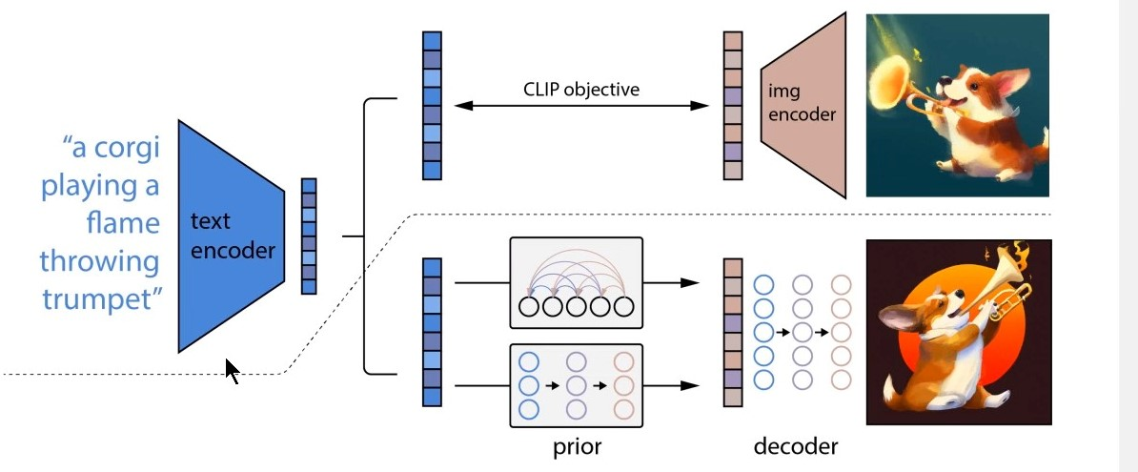

* + The instructor provided the following explanation:
    - “A **text encoder** takes the text prompt and generates the **text embeddings**. These text embeddings are a numeric representation of the input and serve as the input for a model called the **prior**. It generates the corresponding **image embeddings**. Finally, an **image decoder** model generates an actual image from the embeddings.”
* From a text description, **DALL-E** will generate a large set of images, and the images will then be ranked by a second OpenAI neural network called **CLIP** that tries to determine which of the images matches best.
* **CLIP** has 2 components:
  + A text encoder.
  + An image encoder.
* It was trained on ***400 million*** images with text captions that were *scraped from the Internet*.
  + There’s a lot of talk right now of the legal gray zone this presents with regards to copyright law.

### DALL-E 3 Risks and Limitations:

* DALL-E (without guardrails) could generate a wide range of deceptive and harmful content.
  + This could affect how people perceive/trust content in general.
* AI models like DALL-E additionally inherit various biases from their training data, and its outputs could reinforce social stereotypes.

## Introducing ChatGPT and Whisper APIs:

*Note: Resource for this lecture includes the PDF “Robust Speech Recognition via Large-Scale Weak Supervision”, labeled “whisper.pdf”*.

* In this lecture, we’ll cover the **speech-to-text model** known as **Whisper**.
* By the end of the lecture, we’ll be able to ***transcribe audio*** into whatever language it is and translate the transcription into English.
* **Whisper** is a trained Open-Source neural network that approaches human-level robustness and accuracy on English speech recognition.
  + The model supports ***tens of languages*** and was trained on hundreds of thousands of multilingual and multitask supervised data collected from the internet.
* The OpenAI API provides two endpoints:
  + **Transcriptions**
  + **Translations**
* In practical terms, you can use the Whisper model to transcribe audio into whatever language the audio is in, or to translate and transcribe audio into English.

### Transcription:

* We’ll start by creating a new Jupyter Notebook program, “**07_whisper**”. We’ll import the necessary libraries and set our API key from the ***environment variable***.
  + I guess we’ll be using some audio from Ronald Reagan’s speech to the people of West Berlin from July 12, 1987. This is the “Tear Down This Wall” speech.
  + The instructor had included the audio file in Jupyter Notebook, titled “**rr.mp3**”.
  + For comparison’s sake, he had the official transcript of the speech open.
    - I think I’ll just use an mp3 from my music library. Perhaps “**Like a Stone**” by Audioslave because it’s my go-to karaoke song and I know all the words.
* We’re going to open the file in **binary mode** as usual and name it “**audio_file**”. Then we’ll create a storage variable “**transcript**” and use OpenAI’s “**Audio**” and “**translate**” method:

import openai

import os

openai.api_key = os.getenv('OPENAI_CLASS_API_KEY')

with open('05 Like a Stone.mp3', 'rb') as audio_file:

    transcript = openai.Audio.transcribe('whisper-1', audio_file)

* + Note: Obviously you’d want to swap out the name for whatever MP3 you’re using for this.
  + By default, the response type will be in JSON with the raw text included.
* The response I got was pretty close to what I know of the song, though it did add “Thanks for watching!” at the end for some reason:
* The response I got was pretty close to what I know of the song, though it did add “Thanks for watching!” at the end for some reason:

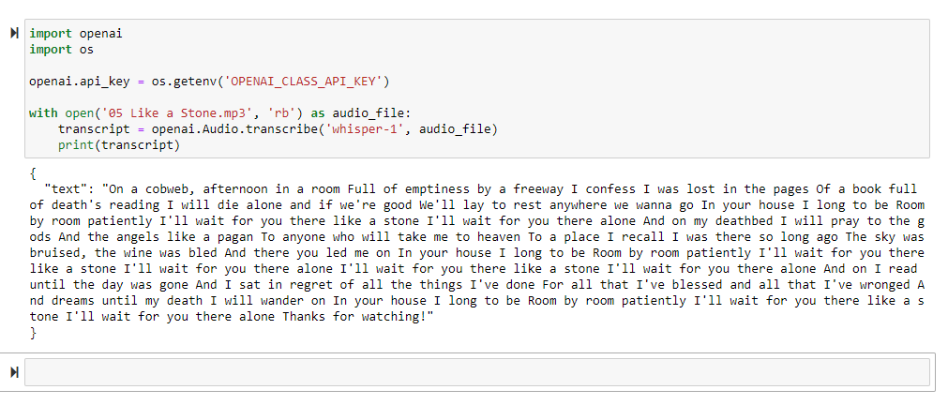

* Let’s see the instructor’s version with the speech:

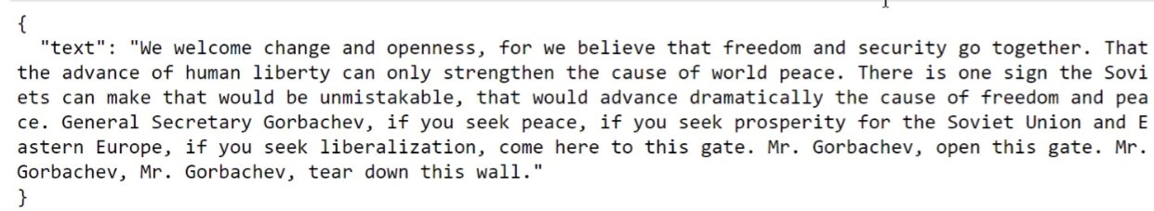

* + Pretty spot-on. I wonder if Whisper does better with regular speech compared to singing, especially when presented with Chris Cornell’s impressive vocal range.
* The instructor noted that audio files are currently ***limited to 25mb*** and the input files that are supported are ***MP3***, ***MP4***, ***MPEG***, ***M4A***, and ***WAV***.

### Translation:

* Besides transcription, Whisper is also capable of translating things into English. We’re going to practice doing an automatic translation.
* The instructor has some sample audio in German, a children’s story (labeled “german.mp3”).
  + I think I’ll go with a song in Spanish that I know, “Primavera” by Santana, off of the album Supernatural.
* For his file, the instructor noted that if you listen to the file, you’ll hear some background noises that you might think would cause problems for the translator. However, this is not the case.
  + Whisper has improved its ***robustness*** to accents, background noise, and technical language.
* The **translations API** takes as input an audio file in any of the supported languages, and then transcribes it into English.
* We’re going to store our file as “audio_file” again with **open**, then create another **transcript** variable, but this time we use **openai.Audio.translate**:

audio_file = open('12 Primavera.mp3', 'rb')

transcript = openai.Audio.**translate**('whisper-1', audio_file) **🡨 🡨 🡨**

print(transcript['text'])

* Note that running the **translate** method seems to take a bit longer than simple transcription.
* Also, it does **not** seem to work with music:

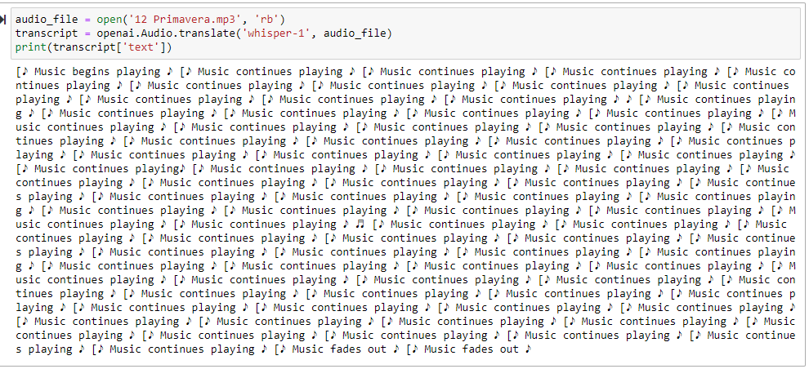

* Here’s the instructor’s version for comparison:
* Here’s the instructor’s version for comparison:

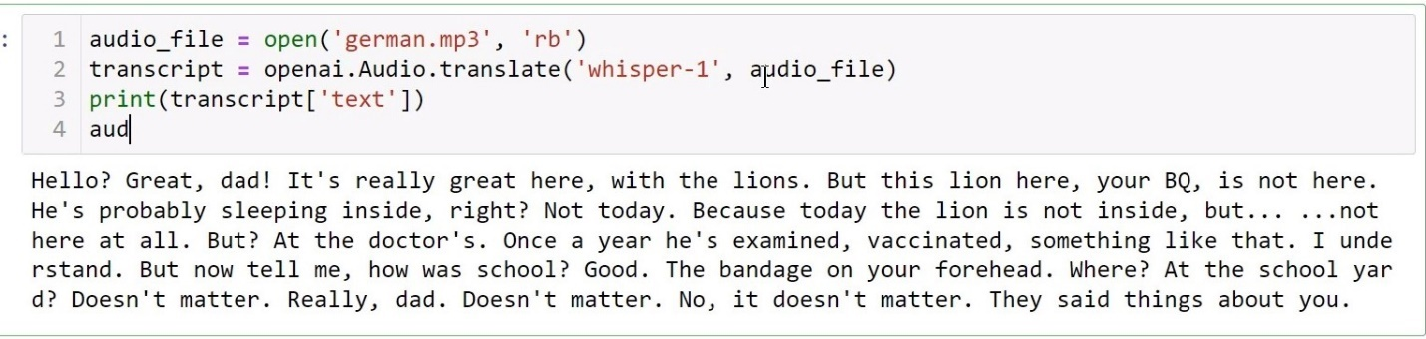

* Also, remember to run **audio_file.close()** because it’s good practice.

# Section 3: Project #1: Zero-Shot Sentiment Analysis Using ChatGPT:

## Project Requirements:

* We’re going to be performing zero-shot sentiment analysis using GPT-3.5 Turbo and Python.
* The instructor did a basic explanation of what one could do with zero-shot sentiment analysis, including:
  + Sentiment analysis
  + Emotion analysis
  + News categorization, including fake news detection
* He then showed the functionality of the finished project.
  + He showed that the project could be used to categorize reviews on his course as either positive or negative.
  + He chose one positive and one negative review to see if the program can classify them correctly:

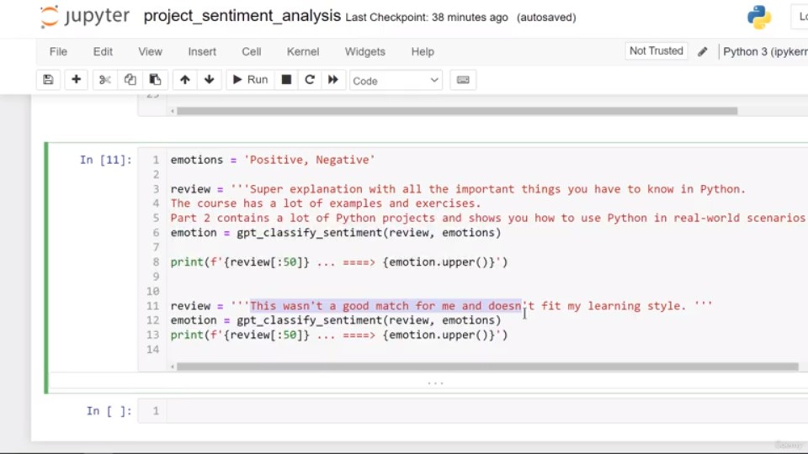

* It appeared to work.

## Building the Application:

* Note that he loaded his API key as a .txt file:

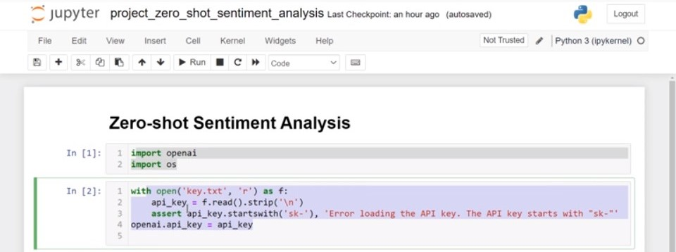

* + However, while I’m going to include that section in my API key seed program in case I want to use a .txt file in the future, I’m going to use my ***environment variable***.
* We start off by creating a new function, **gpt_classify_sentiment** with two variables, **prompt** and **emotions**. Then we use a multi-line ***f-string*** to set a ***system prompt***:

def gpt_classify_sentiment(prompt, emotions):

    system_prompt = f'''You are an emotionally intelligent assistant.

    Classify the sentiment of the user's text with ONLY ONE OF THE FOLLOWING EMOTIONS: {emotions}.

    After classifying the text, respond with the emotion ONLY.

    '''

* To this, we add a response object and set its attributes:

    response = openai.ChatCompletion.create( **🡨 🡨 🡨**

        model='gpt-3.5-turbo',

        messages=[

            {'role': 'system', 'content': system_prompt},

            {'role': 'user', 'content': prompt}

        ],

        max_tokens=20,

        temperature=0

    )

* + We use **max_tokens=20** here because that will be enough tokens for a *single word response*.
  + We set **temperature=0** because we want this program to be *fully* *deterministic*.
* We want to set a variable **r** for our response, extracting the part of the response that we want with **r = response[‘choices’][0].message.content**.
* We also want to handle situations where the response is an empty string:
* We want to set a variable **r** for our response, extracting the part of the response that we want with **r = response[‘choices’][0].message.content**.

def gpt_classify_sentiment(prompt, emotions):

    system_prompt = f'''You are an emotionally intelligent assistant.

    Classify the sentiment of the user's text with ONLY ONE OF THE FOLLOWING EMOTIONS: {emotions}.

    After classifying the text, respond with the emotion ONLY.

    '''

    response = openai.ChatCompletion.create(

        model='gpt-3.5-turbo',

        messages=[

            {'role': 'system', 'content': system_prompt},

            {'role': 'user', 'content': prompt}

        ],

        max_tokens=20,

        temperature=0

    )

    r = response['choices'][0].message.content **🡨 🡨 🡨**

    if r == '':

        r = 'N/A' **🡨 🡨 🡨**

    return r **🡨 🡨 🡨**

* We also want to handle situations where the response is an empty string:
* This is the main function of our application.
* In the next lecture, we’ll test the program.

## Testing the Application:

### Test 1: Basic Tests:

* To start, we’ll define the **emotions** that we’re looking for using a string. We’re keeping this simple and limiting it to just two: ***positive*** and ***negative***.

emotions = 'positive, negative'

* We’ll also define a **prompt**. For this test, we’ll simply hard-code it, but by using different APIs from different applications, we could connect this to Twitter, Reddit, or other social networks, get posts from these, and classify them.

emotions = 'positive, negative'

prompt = 'AI will take over the world.'

* A
* Now let’s call the function:

emotions = 'positive, negative'

prompt = 'AI will take over the world.'

print(gpt_classify_sentiment(prompt, emotions))

* GPT classifies this prompt as ***negative***:

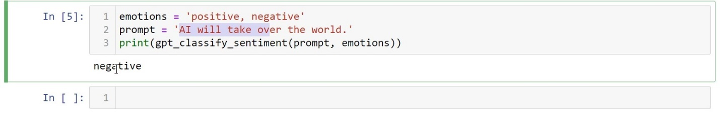

* Now let’s try it with a longer list of emotions:

emotions = "happy, sad, angry, mad, tired, very happy, very sad, very angry, very tired, very mad"

* We’re going to use the prompt “I lost my phone.”:

emotions = "happy, sad, angry, mad, tired, very happy, very sad, very angry, very tired, very mad"

prompt = 'I lost my phone.'

print(gpt_classify_sentiment(prompt, emotions))

* + This one was pretty amusing, because it classifies it as “**very sad**”.
* Now lets do a variation of the first prompt, changing it to “AI will take over the world and destroy the human race.”
* Now lets do a variation of the first prompt, changing it to “AI will take over the world and destroy the human race.”

emotions = "happy, sad, angry, mad, tired, very happy, very sad, very angry, very tired, very mad"

prompt = 'AI will take over the world and destroy the human race.'

print(gpt_classify_sentiment(prompt, emotions))

* + This one returns “**very mad**”, which is interesting.
    - I want to point out that the prompt the instructor used was “AI will take over the world and extinct the human race”; not technically correct, but English isn’t his first language.
    - His version returned “**angry**” instead, though when I run the same prompt I still get “very mad”.
* A few more examples:
  + The prompt “I am going to sleep” returns “tired”.
  + The prompt “Let’s take a break! I can’t do it anymore!” returns “very tired”.
  + The prompt “The company CEO just missed out a $10 million bonus, but he still got a raise” returns “angry”.
* Let’s test with an emoticon:
  + The prompt “😊” returns “very happy”.
  + The prompt “😠” returns “very angry”.

### Test 2: Useful Example: Classifying Reviews:

* Imagine you’re a professional or are hired at a company that gets lots of reviews from its customers.
* We want to classify each review as ***positive*** or ***negative*** using the Python script we’re written.
  + Being able to do so is very useful when there are **a lot** of reviews to classify.
  + We can ***save the results*** to a file or a spreadsheet.
  + We can also ***read a spreadsheet into Python*** and have its contents read by this ***sentiment analyzer***.
* For this example, we’ll define two emotions again: **positive** and **negative**.
* As an instructor, he says he gets 10s of reviews a day. He’s chosen two reviews from one of his course, and he wants to check how the program will classify them.
* The first is a positive review:

emotions = 'positive, negative'

review = '''Super explanation with all the important things you have to know in Python.

The course has a lot of examples and exercises.

Part 2 contains a lot of Python projects and shows you how to use Python in real-world scenarios.

'''

* We’re going to set a variable **emotion** to store/call our **gpt_classify_sentiment** function, inputting this review and our two emotions. We then print out the first 50 characters of our review, and its output sentiment:

emotion = gpt_classify_sentiment(review, emotions)

print(f'{review[:50]} ... ======> {emotion.upper()}')

* This outputs…

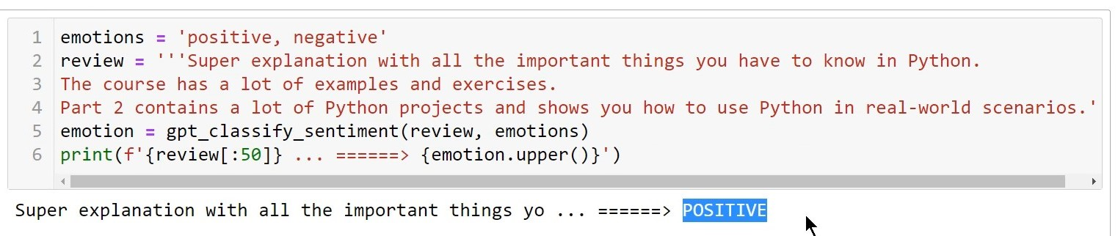

* …or a POSITIVE review.
* Next let’s try a negative review:
* Next let’s try a negative review:
* We’ll copy/paste the portions of code we can reuse, but insert a new review into the program:

emotions = 'positive, negative'

review = '''This wasn't a good match for me and doesn't fit my learning style.''' **🡨 🡨 🡨**

emotion = gpt_classify_sentiment(review, emotions)

print(f'{review[:50]} ... ======> {emotion.upper()}')

* This time we get…

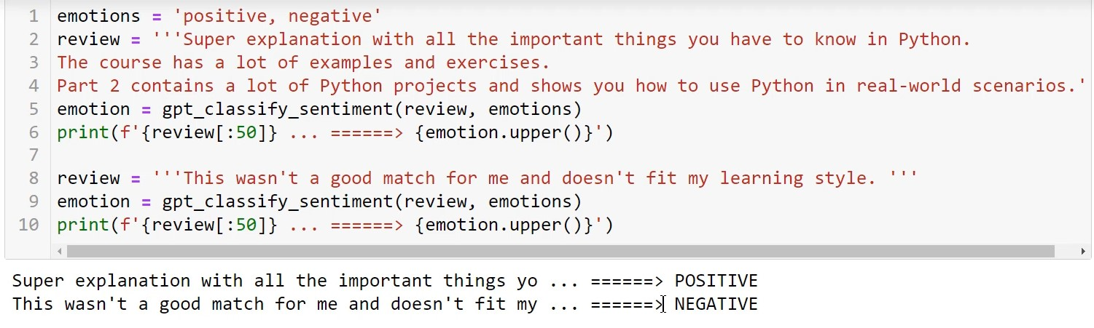

* …a NEGATIVE review.
* So our program appears to be doing what it’s supposed to, and this test was a success.
* For our next test, we’ll be setting the program to be a *fake news detector*.

### Test 3: Useful Example: Fake News Detector:

* For our last test, we’ll be making a ***fake news detector***.
* This is an important application of this technology because it can help prevent the spread of false information, which can cause real harm in the real world, or have serious consequences.
* We’ll start by setting our **emotions** variable to ‘**True, False**’.
* Then we’ll use the **prompt** ‘**The moon landings were all faked.**’
* We’ll call our function with these inputs, then print the results again using an f-string:

emotions = 'True, False'

prompt = 'The moon landings were all faked.'

emotion = gpt_classify_sentiment(prompt, emotions)

print(f'{prompt} ====> {emotion.upper()}')

* 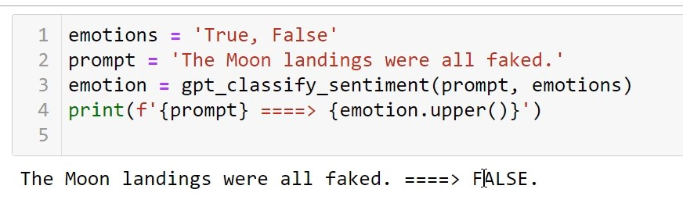And as a result, we get…
* … **FALSE**
* Now let’s test with another prompt: “**The earth is flat.**”:

prompt = 'The earth is flat.'

emotion = gpt_classify_sentiment(prompt, emotions)

print(f'{prompt} ====> {emotion.upper()}')

* 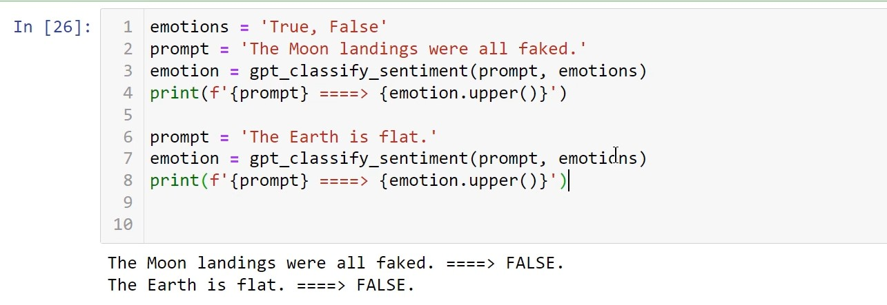And we get…
* **FALSE**. Seems to be working well so far.
* Let’s try one more: “**Elvis Presley died in 1978**.”:
* Let’s try one more: “**Elvis Presley died in 1978**.”:

prompt = 'Elvis Presley died in 1978.'

emotion = gpt_classify_sentiment(prompt, emotions)

print(f'{prompt} ====> {emotion.upper()}')

* This time it returned **FALSE** again because Elvis died in **1977**.

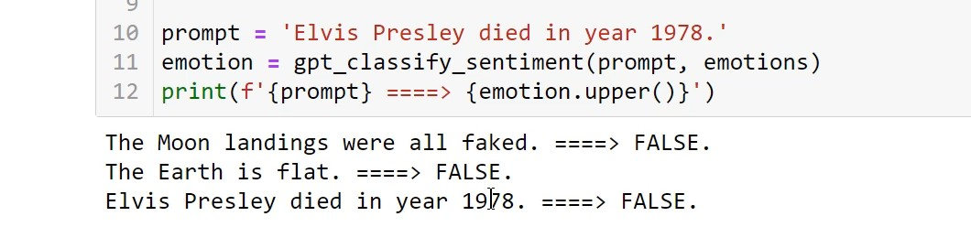

* Swapping 1978 out for 1977 returns **TRUE**:

prompt = 'Elvis Presley died in 1977.'

emotion = gpt_classify_sentiment(prompt, emotions)

print(f'{prompt} ====> {emotion.upper()}')

* New results:

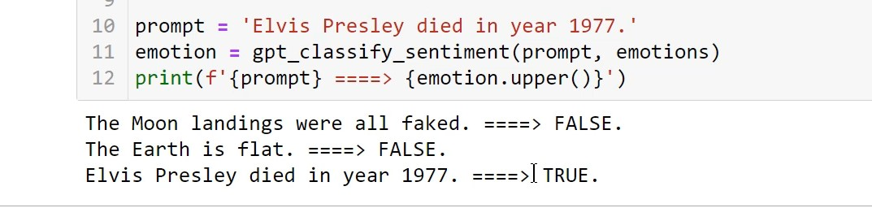

* Our fake news detector seems to be working quite well so far.
* Let’s try one more, something a little less to do with common knowledge: **prompt = ‘Quantum entanglement has been experimentally demonstrated with photons, electrons, and other particles**’:

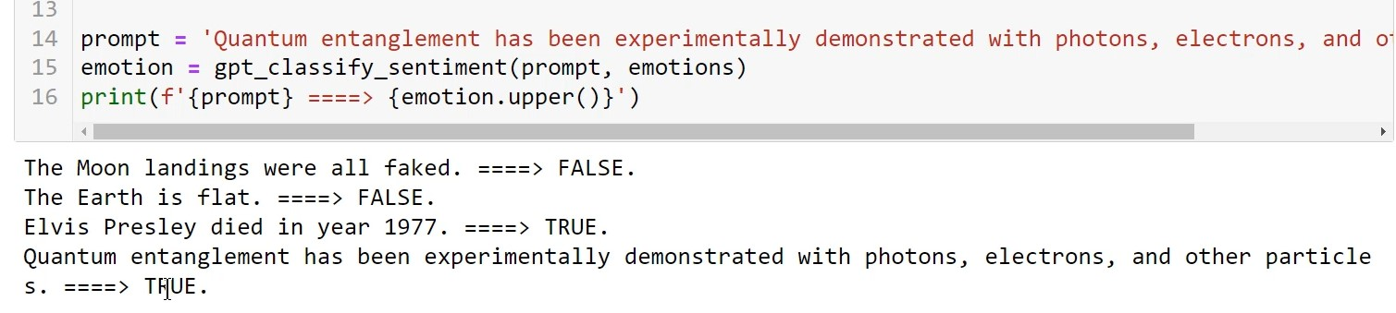

* And that appears to be true as well.
* Our sentiment analyzer seems to be working very well.
* We can now connect it to real-world applications to make it an even more useful tool.
* In the next few lectures, we’ll be building a **front-end** to connect our application to, create a **web layout**, and **save and display history**, all using **Streamlit**.

## Building a Front-End Using Streamlit:

* The instructor began the lecture by stating that, while using Jupyter Notebook for prototyping and testing an application is useful, it’s not ideal for production or end user applications.
* If we want our application to be accessible to everyone (not just developers), we’ll want to create a **web app** or a **front-end interface** for it.
* This is where **Streamlit** comes in.



* **Streamlit** is an open-source Python library that simplifies the creation and sharing of custom web apps and front-ends for **generative AI**, **machine learning**, and **data science**.
  + Using Streamlit, we can give our application a user-friendly interface and make our app widely available to users.
  + **Note:** At the end of this course, the instructor has included an entire section designed for Streamlit beginners.
    - He suggests going and taking that section before coming back here.
* For this, we’ll use an IDE such as PyCharm or VSCode.
  + Using Jupyter Notebook wouldn’t work well for this, because creating a web app inside of another web app can be problematic.
* A
* A
* A
* A
* A
* A
* A
* A
* A
* A
* A
* A
* A
* A
* A
* A
* A
* A
* A
* A

# Section 12: [Appendix]: Creating Web Interfaces for ML/DS Applications Using Streamlit:

**Note:** I’ve created this section of notes while in the middle of **Section 3** lecture 4, “Building a Front-End Using Streamlit”. This is because during that lecture, the instructor pointed out this bonus section for people who are new to **Streamlit**, and suggested that we run through it before coming back.

## Section Resources:

* The instructor pointed to a Google Drive address:
  + <https://drive.google.com/drive/folders/1BkdFVZ4pE4eAabkGz7SH0HK1cwDww8eJ?usp=sharing>
* This location contains all of the source files for the section, but the instructor suggests writing all code on your own, as it is good practice.

## Introduction to Streamlit:

* AI has the potential to make us much more efficient.
* Jupyter Notebook is a great tool for writing and testing code, prototyping, and experimenting, but it’s not designed for production or for end-user usage.
* A
* A
* A
* A
* A

# Template: Code Box:

**user_input = float(input("Enter temperature: ")) 🡨 🡨 🡨**

print(weather_condition(user_input))

from tkinter import *

window = Tk() **🡨 🡨 🡨 Create window**

l1 = **Label**(window, text="**Title**") **🡨 🡨 🡨 Create labels**

l1.grid(row=0, column=0)

l2 = **Label**(window, text="**Author**") **🡨 🡨 🡨**

l2.grid(row=0, column=2)

window.mainloop()

For use whenever code needs to be presented in notes.